 | Weekly Insights | Oct 23, 2025
 | Item | Page
 | Stories of the Week | 1
 | Corn | 30
 | Wheat | 32
 | Soybeans | 34
 | Soybean Meal | 36
 | Soybean Oil | 38
 | Weekly Prices | 40

Executive Summary
Corn – Modest Futures Lift, Carry Narrows on Gulf Strength
December corn climbed 9¢ to $4.32/bu, marking a two percent weekly advance, driven by initial short-covering and emerging export demand. The Dec/Mar spread narrowed to 13¢ (65 percent of full carry), it’s firmest in five weeks, as Gulf exporters competed aggressively for nearby ownership. CIF basis rose 3–5¢ on improved demand from Mexico and Colombia, while river bids in the ECB softened as farmer selling picked up. Export inspections reached 1.19 MMT for the week ended Oct 23, still above last year’s pace despite a slight pullback from the prior week.

Soybeans – Gulf Basis Pops on China Buys, Spreads Hold
January 2026 soybeans advanced 56¢ to $10.92/bu, a 5.5 percent gain that pushed it to a 15-month peak, fueled by news of several Chinese buys leading into the Trump–Xi summit. CIF Gulf basis firmed 5–10¢ on the week as demand shifted forward, while Jan/Mar held near 11¢ (50 percent of full carry). Export inspections fell to 1.06 MMT (–33 percent w/w) as recent sales had yet to load, but processor bids remained firm at +20 to +30¢ across much of the Midwest, underpinned by strong crush margins.

Wheat – Short Covering Leads, Export Inspections Lag
December SRW wheat climbed 28¢ to $5.32/bu, a five percent gain, with speculative short covering carrying the market higher despite lackluster U.S. competitiveness. The Dec/Mar spread narrowed to 15¢ (60 percent of full carry), while FOB values at the Gulf and PNW remained uncompetitive versus Black Sea. Russian 12.5 percent FOB offers rose $5/mt as Moscow raised the floating export tax, though volumes remained robust. U.S. inspections dropped to 259k mt, their lowest weekly total since early September.

(Carry % calculated assuming 7% annual interest and \$0.05/bu per month storage/insurance cost over the spread interval.)

Macro/Policy – Trump–Xi Trade Optics, USD Eases, Crude Recovers
Futures for soy and corn reacted to build up ahead of the Oct 30 Trump–Xi meeting, with market participants anticipating Chinese soybean buying if diplomatic tone remained constructive. While USDA export sales reporting remained suspended due to the federal shutdown, traders cited unconfirmed private sales activity. The U.S. Dollar Index eased to 98.6 (–0.2 w/w), while the Brazilian real held near 5.39. Crude oil rebounded to $60.35/bbl, supporting ethanol and soy oil product margins.
Weather – U.S. Harvest Progresses, Argentina Recovers, Brazil Mixed

Harvest advanced rapidly under dry conditions across the Midwest. U.S. harvest is estimated at near 72 percent complete and soybeans at near 84 percent, with progress largely wrapped in IL, IA, and MN. Southern Brazil received scattered showers, offering partial relief, but central zones, including Mato Grosso and Goiás, remained critically dry through Oct 29. In Argentina, widespread 25–50 mm rainfall midweek accelerated corn planting and helped stabilize early wheat development.
What’s Next (Oct 30 – Oct 6):
Trump–Xi summit: confirmation of additional China purchases could extend soy/corn rally
USDA report resumption: crop progress and export sales could backfill up to 3 missed weeks
Mato Grosso rainfall: follow-through needed to support soy planting pace
Gulf lineups: flash sales, if confirmed, may show in late Nov/early Dec soy shipments
Russia: Nov 1 tax adjustment and export pace to gauge FOB floor
Ethanol: EIA (Nov 5) expected to show recovery in production after prior week’s dip
Table A – CME Futures (Front Contracts)
(Prices in USD per bushel, volume/open interest in contracts)
Contract (Front Month) | 10/22/2025 Close | 10/29/2025 Close | Change (Δ) | Δ% | 5-day Realized Vol* | Open Interest Δ
Corn (Dec ’25) | $4.23 | $4.32 | +$0.09 | +%2.1 | 9% (ann.) | -11.4k (est.)
Soybeans (Jan ’25) | $10.36 | $10.92 | +$0.56 | +%5.4 | 12% (ann.) | +7.9k (est.)
Wheat (Dec ’25) | $5.04 | $5.32 | +$0.28 | +%5.6 | 7% (ann.) | -5.2k (est.)
5-day realized volatility estimated from daily settlement price changes.
Actual contract open interest changes are estimated; total corn OI rose slightly as new-crop hedges built, while wheat OI fell with Sep contract deliveries.
Table B – Key Calendar Spreads & % of Full Carry
Spread (Crop ‘25→‘26) | 10/22  Quote | 10/29  Quote | Δ (carry) | % Full Carry* | Market Implication
Corn Dec–Mar | -$0.14 | -$0.13 | +0.01 | 65% | Nearby Gulf demand firming vs. interior harvest flow
Soy Jan–Mar | -$0.18 | -$0.11 | +0.07 | 50% | Crush pull holding January, export sales still Brazil-facing
Wheat Dec–Mar | -$0.16 | -$0.15 | +0.01 | 60% | Black Sea supply caps U.S. exports pace, carry remains commercial
Assumes 7% annual interest + $0.05/bu/month storage/insurance. Full carry (3 months) ≈ $0.22–$0.23 for corn & SRW wheat; (2 months) ≈ $0.22 for soybeans. % of full carry = (calendar spread ÷ calculated full carry).
Table C – Notable International Futures (weekly moves, if significant):
Exchange (Front Mo) | 10/22 USD Price | 10/29 USD Price | Δ% | Notes
Dalian Corn (Jan) | ¥2,115($7.55/bu) | ¥2,115($7.55/bu) | +0% | China corn futures steady on moderate feed demand; premium over import parity due to quotas.
Dalian Soymeal (Jan) |  | ($11.84/bu) | -9.4% | Soy meal eased; steady hog demand amid stable inclusion rates, but supply pressure weighs.
  ¥3,420($13.12/bu)
  ¥3,100
B3 (São Paulo) Corn (Nov) |  |  | -4.7% | Brazilian corn softened on steady domestic logistics and U.S. competition, export pace firm.
  R$67.88($12.38)
  R$64.68($12.00)
Euronext Wheat (Dec) |  |  | +0%
  €190 ($220)
  €190 ($220)
  EU wheat held steady amid ample stocks and slow demand, capped by cheap Black Sea offers.

Corn Market Deep Dive
Futures & Spreads: December 2025 corn futures closed at $4.32/bu on Oct 29, up 9¢ or two percent from the prior week, with gains concentrated early amid fund short covering and stronger Gulf basis levels that tapered off later. The Dec ’25–Mar ’26 spread narrowed slightly to 13¢ carry (65 percent of full carry, assuming seven percent interest + $0.05/bu/month storage and insurance), among the tightest readings since mid-September. With USDA reports still offline, traders leaned on basis and barge signals to track demand. Realized volatility stayed low (15 percent), and spreads remained resilient even as flat price gains stalled, reflecting firm nearby pull from exporters and processors.
Funds & Positioning: CFTC data remains unavailable due to the continued federal shutdown. CME open interest in December corn dropped by 11.4k contracts on Tuesday’s rally (Oct 28), consistent with managed money short covering. Total OI across corn futures was steady w/w, suggesting limited new commercial hedging or fund reentry. Vol and volume patterns pointed to a rotation from outright shorts into calendar spread longs and basis-linked positioning, with no sign of speculative aggression in either direction. Market chatter pegged managed money still modestly net short, with no incentive to press until export or ethanol trends diverge.
U.S. Cash & Basis: CIF Gulf basis rose to +55–57¢ over Dec, up 3–5¢ w/w, buoyed by active demand from Mexico and Colombia and tighter barge logistics. Lower Mississippi river bids remained weak, ranging from –60¢ to –75¢ under Dec, as low water conditions pushed barge freight to 400–425 percent of tariff. Illinois River basis softened to –32¢ (–4¢ w/w), while Ohio River bids held near –20¢, both pressured by stronger farm selling. Interior processor bids held firm: IA and NE ethanol plants posted +10¢ to +15¢ over Dec, with steady grind margins. National basis was estimated near –42¢ under, 2¢ weaker w/w, based on private broker data in absence of AMS reports. River vs interior spreads continued to widen on logistics.
Export Flows: USDA FGIS reported corn inspections at 1.19 MMT for the week ending Oct 23, down from 1.32 MMT prior week but still ahead of last year’s cumulative pace. Export sales reporting remained suspended. Gulf FOB offers stayed near $222/MT ($5.63/bu), undercut by Brazilian values into Asia by 20–25¢/bu. Traders reported additional cargo interest from Mexico, Colombia, and South Korea, though barge costs limited new sales beyond the Americas. Gulf–Asia competitiveness remains contingent on Brazil’s export fade and Black Sea freight shifts.
International Trade: Brazilian FOB Santos offers averaged $203–205/MT ($5.20–5.25/bu), maintaining a $0.25/bu advantage over the U.S. Gulf. ANEC lowered its October corn export forecast to 6.19 MMT (Oct 28), down from 6.57 MMT a week earlier, citing late-season lineup rollbacks and firm domestic basis. Interior bids in Mato Grosso firmed to BRL 46/60kg on reduced grower sales. Argentina’s Up-River FOB values held near $205/MT, supported by weak farmer selling ahead of the Nov 24 runoff and continued FX uncertainty. BCR reported planting at 33.8 percent complete, aided by recent rainfall. China remained absent from the U.S. market, instead sourcing Brazil and Ukraine corn; Dalian Jan corn hovered near ¥2,540/MT ($6.40/bu), still above import parity. B3 Jan corn edged higher to BRL 62.20 ($5.21/bu), supported by domestic logistics.
So What? Corn is still a carry market, but recent price and spread action signal improving spot demand. The Dec/Mar spread narrowed to its firmest in weeks, while CIF basis climbed on solid interest from Mexico and Colombia. Despite river bottlenecks, interior processor bids held steady, reflecting ongoing ethanol strength. Export momentum remains regional rather than global, competitiveness into Asia is still capped by Brazilian FOBs and freight. Until either export pace broadens or Chinese demand returns, corn futures likely drift inside the $4.20–$4.40 range, with basis and spreads steering price tone.

Soybean Market Deep Dive
Futures & Spreads: January 2026 soybeans settled at $10.92/bu on Oct 29 (+56¢ w/w, +2.5 percent), extending gains on confirmed Chinese purchases and continued dryness in central Brazil. The Jan ’26–Mar ’26 spread held firm near 11¢ carry (50 percent of full carry, using seven percent interest and $0.05/bu/month storage/insurance), reflecting strong nearby demand from crushers and exporters. Implied vol remained soft despite flat price strength, with the curve maintaining a mild carry through Q1. Deferred spreads narrowed slightly, but no inversion emerged, underscoring the market’s balanced tone between domestic demand and slow export flow.
Products & Crush: Board crush margins remained profitable, supported by firm meal demand and positive yield adjustments in spot processing. Soybean oil faded midweek alongside crude, with BOF6 retreating to 51.0¢/lb (–1.4¢ w/w), while eastern soymeal values added $4–7/short ton on tight rail and truck logistics. Gross board crush stayed above $1.45/bu, keeping processors aggressive on basis. Indiana and Ohio plants maintained strong bids of +60–70¢/F for nearby slots, supported by heavy meal offtake into livestock and dairy sectors. While official NOPA data remains paused, private estimates showed October crush on pace to exceed year-ago levels.
Funds & Positioning: No CFTC report was released for the week, as the shutdown entered its fifth week. CME open interest rose 7.9k contracts (+0.8 percent w/w), likely driven by fresh commercial hedging and roll activity rather than fund exposure. Trade chatter suggested funds were modestly net long but not pressing upside, with Chinese demand still intermittent and spreads showing no sign of nearby tightness. Price action pointed to end-user strength rather than speculative conviction.
Cash & Basis: CIF Gulf basis firmed to +80–82¢/F (+5–7¢ w/w) as barge congestion and late-month vessel stems pulled nearby values higher. River basis remained soft: Illinois River fell to –32¢/F (–2¢ w/w), and Lower Miss stayed near –75¢ under. Cairo-Memphis barge freight hovered around $20/ton, capping river competitiveness. PNW offers for Dec–Jan held steady at +110¢ over, while processor bids in Iowa, Indiana, and Ohio ranged from +60 to +75¢, driven by board crush strength. National average basis was estimated at –72¢/F, modestly stronger vs. last week’s –74¢, with wide regional spreads reflecting logistics strain rather than harvest surplus.
Trade Flows & International Competition: USDA FGIS inspections totaled 1.06 MMT for the week ending Oct 23, down from 1.59 MMT prior, as recent China purchases had not yet loaded. Brazil’s FOB Santos soybeans traded near $437–$442/MT ($9.95–$10.05/bu), maintaining a $0.30–$0.40/bu discount to U.S. Gulf offers. ANEC trimmed October export forecasts to 7.00 MMT (from 7.34 MMT), citing delayed lineups and Mato Grosso dryness. Argentine FOBs held near $455/MT ($10.40/bu), supported by firm local crush margins and constrained new-crop sales. Chinese crushers booked 2–4 U.S. cargos early in the week but remained mostly focused on Brazilian supply, citing easier VAT processing and freight availability.
So What? Soybeans persist in a split-market dynamic: crushers are bidding actively on meal and board margins, while export demand remains patchy and largely Brazil-facing. Gulf strength and firm Jan/Mar spreads point to solid nearby consumption, but board levels stay tied to central Brazil rainfall and Chinese reengagement. Until one of those variables shifts decisively, futures likely stay rangebound between $10.70 and $11.00, with basis and spreads doing the heavy lifting beneath the board.

Wheat Market Deep Dive
Futures & Spreads: Chicago SRW December futures rose 28¢ to $5.32/bu on Oct 29 (+6 percent w/w), recovering from contract lows on short covering and modest strength in corn and soybeans. The Dec ’25–Mar ’26 spread narrowed to 15¢ carry (60 percent of full carry, assuming 7 percent interest + $0.05/bu/month storage/insurance), slightly firmer w/w but still offering ample commercial incentives. Implied volatility remained low (18 percent), with wheat largely following broader row crop sentiment. KC HRW December rose 9¢ to $5.69, while Minneapolis HRS December added 6¢ to $6.15.
Global Supply & Demand: Russian 12.5 percent protein wheat FOB offers strengthened to $235/MT, a $5 rise w/w, following Moscow's revised floating export tax that boosted domestic replacement values. Despite the uptick, Russia remained the dominant origin into GASC and Turkish tenders. French wheat (Rouen) was offered near $232/MT but struggled to gain share amid strong Black Sea flows. Argentina’s crop outlook held steady around 21 MMT, with SMN citing improved soil moisture. East Australia received light rain midweek, stabilizing late wheat development after prior heat stress. U.S. HRW planting advanced steadily under mostly dry conditions in the central Plains; early emergence remained uneven, particularly in western KS and OK, but no widespread yield concerns were flagged.
Cash & Basis: U.S. FOB SRW Gulf offers remained around $227/MT ($6.80/bu equivalent), still $20–25/MT above Russian competition into MENA and Southeast Asia. HRW FOB held near $240/MT. Export basis at the Gulf eased another 2–3¢ as shipping programs stayed light and river costs remained elevated. Domestic milling basis was flat to slightly weaker across the Southern Plains, with Oklahoma and Texas bids slipping 2–4¢ on the week. Central state mills (KS, MO, NE) reported slow grind rates and full nearby coverage, with little need for spot bushels. Interior basis levels continued to reflect carry incentives and storage economics, not active demand.
Trade Flows: USDA FGIS inspections totaled 259k MT for the week ending Oct 23, down 46 percent from the prior week’s 493k and the weakest total since early September. U.S. exports continued to lag amid poor FOB competitiveness. Russia booked additional volume into North Africa and Middle East tenders, reinforcing its anchor role in global trade. U.S. exporters remained sidelined by both price and logistics, with no flash sales reported and no USDA Export Sales updates due to the government shutdown.
Speculative Positioning: CFTC positioning data was not published for a fifth straight week. CME open interest in SRW futures fell 5.2k contracts w/w, consistent with early-week short covering. Trade desks continued to estimate managed money holding a large net short in SRW, though recent price strength may have forced some position trimming. Without official COT data, speculative sentiment remained opaque, though futures action reflected technical relief rather than fresh bullish conviction.
So What? U.S. wheat continues as a supporting actor on the world stage, constrained by robust Black Sea volumes and narrow competitive edges. Recent gains were driven more by short-covering than fresh demand, as FOB levels remain $20–25/MT above rival origins. Spreads confirm ample storage incentives, and basis softness suggests little urgency from buyers. Unless Russian logistics slow, Southern Hemisphere weather worsens, or funds shift posture, U.S. wheat stays rangebound. The complex continues to track row crops and global macro signals, rather than setting its own direction.

U.S. Cash Market & Basis
Corn: River basis remained soft as low Mississippi River levels continued to limit barge drafts and inflate freight. Illinois River bids fell to –32¢/Z (–2¢ w/w), while Lower Miss held near –65¢ to –78¢ under, with spot freight still quoted near $20.00/ton for Cairo–Memphis lanes. CIF Gulf basis strengthened to +55–57¢/Z (+3–5¢ w/w), driven by steady Mexican and Colombian demand and tighter late-month barge supply. Interior processor bids in Iowa and Nebraska stayed firm near even money to +15¢, supported by stable ethanol margins and active feed usage. National average corn basis was estimated at –42¢/Z (–2¢ w/w), slightly weaker on the week, consistent with strong carry structure and easing flat price.
Soybeans: CIF Gulf bids rose to +80–82¢/F (+5–7¢ w/w), lifted by confirmed Chinese purchases and tighter barge spot capacity. River basis was flat to lower, with Illinois River bids near –32¢/F (–2¢ w/w), and Lower Miss basis still wide at –72¢ to –78¢ under. Midwestern elevator bids remained near –75¢ to –80¢/F, pressured by harvest flow and slow export loadings. Eastern processors (IN, OH) remained aggressive at +65–75¢/F, anchored by strong board-crush margins and firm soymeal values. National average basis was pegged at –72¢/F, slightly firmer vs. the prior week, though still weak by seasonal standards due to congestion, not supply pressure.
Wheat: U.S. FOB offers continued to lag global values. HRW 11.5% protein held near $240/MT and SRW near $227/MT, both uncompetitive against Black Sea offers. Gulf basis eased another 2–3¢ on light export interest and quiet barge activity. Domestic milling bids across OK, KS, and TX slipped 2–4¢ w/w, reflecting adequate pipeline coverage and slow grind demand. Central Plains elevators continued to post nominal interior basis levels, tied more to carry spreads than spot pull. Interior demand remained flat, with no major basis movement tied to new milling or rail activity.
So What? Basis patterns continued to diverge: processors held steady as margins remained positive, while river markets remained under pressure from barge constraints and global trade dynamics. Export-facing basis showed isolated strength in soybeans, but logistics kept most grain bottled up inland. While Mississippi stages remain subdued and FOB spreads remain wide, commercial players remain incentivized to carry grain rather than move it.

International Cash & Trade Flows
Brazil: Brazil sustained its leading role in corn and soybean pricing, despite ANEC's slight downward adjustments to October export estimates. Soybean exports were pegged at 7.00 MMT (down from 7.34 MMT), and corn exports at 6.19 MMT (down from 6.57 MMT), reflecting late-month shipment rollbacks and slow loadings in northern ports. FOB Santos soybeans averaged $437–$442/MT ($9.95–$10.05/bu), keeping a $0.30–$0.40/bu discount to U.S. Gulf. Corn FOB offers held steady near $203–$205/MT ($5.15–$5.20/bu), sustaining a $25/MT advantage into Asia. Interior logistics remained functional despite dryness in Mato Grosso, where planting was delayed. Paranaguá and Santos lineups moved steadily, with exporters continuing to dominate China and Southeast Asia flows.
Argentina: Up-River corn and soy FOBs held steady at $205/MT and $455/MT respectively, as farmer selling slowed ahead of the Nov 24 runoff election. The temporary zero-export-tax window expired Oct 31 without extension, prompting an end-of-month sales push but limited forward coverage. Rosario crushers reported steady throughput and adequate raw supply. River logistics remained uncongested. Argentina’s wheat harvest preparations progressed in the north, with private estimates still near 21 MMT for 2025/26. Parallel peso rates stayed above 1,000/USD, maintaining FX-driven marketing incentives despite uncertainty around the incoming administration’s grain policy stance.
China: China booked 2–4 U.S. soybean cargoes early in the week ahead of the Trump–Xi meeting, but remained focused on Brazilian offers for Nov–Dec. Dalian Jan soybeans held near ¥4,115/MT ($11.10/bu), while soymeal futures traded at ¥3,100/MT ($418/ST), reflecting steady crush margins. Jan corn traded around ¥2,540/MT ($6.40/bu), still well above import parity, but no new U.S. corn purchases were reported. Biotech protocols and TRQ quotas continued to restrict interest. No reserve auctions or government stock moves were announced.
EU / Black Sea: Russian FOB 12.5 percent wheat rose to $235/MT (up $5 w/w) as Moscow increased its floating export tax, but volumes continued at full pace into GASC and Turkish tenders. EU wheat offers from Rouen held near $232/MT, struggling to stay competitive. French exporters cleared prior sales to Algeria and Morocco, but no major new buying emerged. Russian soymeal and corn increasingly displaced U.S. cargoes into MENA markets, aided by lower Black Sea freight and favorable ruble terms. U.S. exporters remained sidelined in key European and North African slots.
Other Origins: No major shifts were reported from Canada or Ukraine. Ukrainian corn reappeared in a handful of Balkan and Turkish trades, but volumes were modest. Canadian spring wheat moved into Mexico and Southeast Asia in container and bulk parcels, but at a slower pace than earlier in Q3. No material offers emerged from South Africa or India this week.
So What? Global trade flows remain dominated by Russia and Brazil, with Argentina’s election calendar adding short-term volume but no pricing shift. China remains hesitant on U.S. origin outside token soybean purchases, while high barge freight continues to block Gulf competitiveness. Until FOB spreads compress or river costs ease, U.S. corn, soy, and wheat will struggle to reclaim share. Basis and spreads continue to reward storage over movement.
Key Fundamentals & Reports (Oct 16 – Oct 22)
Government Shutdown: The U.S. government shutdown extended into its 29th day as of Oct 29, continuing to suspend USDA, CFTC, and related federal data releases. No budget agreement emerged during the week, and agency operations remained frozen. Markets once again went without official updates on export sales, crop progress, or fund positioning. Fee-funded FGIS inspections and independent agency figures (EIA, ANEC) remained the only reliable datapoints. Any restart in USDA reporting will likely come with backlogged multi-week data and publication lags into mid-November.
Crop Progress (estimated as of Oct 27): U.S. corn harvest is estimated at approximately 72 percent complete and soybean harvest near 84 percent, both ahead of five-year averages (55 and 67 percent, respectively). Favorable weather allowed uninterrupted fieldwork across the Corn Belt, especially in IL, IA, and MN. Most of the Midwest experienced dry conditions, with some areas nearing completion. No new USDA conditions or progress ratings were published, but trade consensus pointed to steady crop quality and no frost damage following earlier October cold snaps.
Export Inspections (USDA FGIS – week ending Oct 23, published Oct 28): Corn inspections totaled 1.19 MMT (down from 1.32 MMT prior), with Mexico, Colombia, and Japan leading destinations. Soybean loadings dropped to 1.06 MMT (–33 percent w/w), reflecting timing gaps in Gulf shipments despite active Chinese purchases. Wheat inspections fell to just 259k MT, the lowest since early September, as Black Sea FOBs remained dominant. Western Hemisphere demand continued to support corn and soybean flows, while wheat lagged under FOB pricing constraints.
Export Sales (USDA FAS, not published): No export sales data were released during the week. The last available update remains for the week ending Sep 18 (published Sep 25), leaving traders to rely on vessel lineups and private booking chatter. Market participants cited at least 2–4 soybean cargoes sold to China during the week ending Oct 25, but these have not been officially confirmed due to the reporting blackout.
Ethanol Production & Stocks (EIA – week ending Oct 25 / published Oct 29): Ethanol production declined slightly to 1.091 mbpd (–0.8 percent w/w), but remained 1.2 percent above the same week last year. Ethanol stocks were reported at 23.3 mb, flat w/w. Margins stayed positive as front-month gasoline and corn prices moved in tandem. Weekly grind implied 104 mbu of corn use, keeping processors active and basis supported in the interior.
NOPA Crush: No new crush data were released during the window. The next scheduled NOPA report, covering October volumes, is expected Nov 15. The September crush record of 197.9 mbu (reported Oct 15) remained the reference point for trade expectations. Eastern soymeal basis stayed firm, reflecting continued end-user pull.
CFTC Commitments of Traders: No new COT report was published, marking a full month without official fund position updates. Trade estimates continued to peg managed money net short 50k contracts in corn and 95k in wheat, with soybeans near flat or slightly net long. CME open interest shifts offered little evidence of fresh directional conviction.
So What? For the fifth week running, trading proceeded without government data oversight. Independent assessments indicate harvest progress surpassing norms, alongside minimal concerns over quality or output. Export inspections confirmed steady corn flow and lighter soybean loadings, while wheat remained structurally weak. Ethanol grind stayed supportive, and domestic crush demand continued to anchor interior bids. Until USDA resumes reporting and Brazil’s weather pattern resolves, trade direction will continue to rely on physical flows, barge logistics, and processor-led basis signals.

International Reports:
Brazil – ANEC & Weather Updates: ANEC revised October soybean exports down to 7.00 MMT (from 7.34) and corn to 6.19 MMT (from 6.57), citing lineup delays in northern ports and lighter late-month vessel nominations (published Oct 28). FOB Santos values averaged $437–$442/MT for soybeans and $203–$205/MT for corn, maintaining a clear competitive edge into Asia versus U.S. Gulf. Mato Grosso planting remained delayed by central dryness, with IMEA reporting progress at 60 percent (vs. 56 percent last year). Weather models showed modest relief starting Oct 29, though accumulated rainfall remained well below normal for the month. The BR-163 corridor operated without disruption, and Paranaguá lineups indicated continued Chinese buying interest for November arrival. CONAB did not publish any new bulletins during the window.
Argentina – Export Tax Expiration and Grain Selling: With the zero-export-tax window closing Oct 31, farmer selling accelerated during the week, especially for old-crop corn and soybeans. Up-River FOB offers held at $455/MT for soybeans and $205/MT for corn, supported by steady nearby demand and weaker peso incentives. Private exporters estimated 2.3 MMT of soybeans and 1.4 MMT of corn booked for October shipment, consistent with the surge seen in late September. The Ministry of Agriculture and Rosario Grain Exchange did not publish updated figures. Wheat harvest remained 2–3 weeks away in key northern zones, with production expectations holding near 21 MMT. Parallel peso rates held firm above 1,000/USD, sustaining FX-driven marketing urgency.
China – Soybean Buying Signals, Still Cautious on Corn: Trade chatter indicates Chinese state crushers picked up 2–3 U.S. soybean cargoes during the week, with stems reportedly targeted for late November and December arrival as talks loomed. No flash sales surfaced amid the ongoing USDA shutdown. Dalian January soybeans hovered near ¥4,115/MT ($11.10/bu), soymeal around ¥3,100/MT ($418/ST), and corn at ¥2,540/MT ($6.40/bu), remaining above import parity. TRQ and biotech hurdles continued to cap U.S. corn inflows, while crushers stayed selective on forward U.S. bean bookings despite competitive CFR values. No new customs, CNGOIC, or MARA releases emerged during the window.
Black Sea / EU – Russia Maintains Control: Russian FOB 12.5 percent wheat climbed to $235/MT on Oct 29 following tax hikes, but export volumes remained high. Russia secured additional sales into Egypt (GASC) and Turkey via private channels. Ukrainian FOB wheat held near $238/MT, with corn offers closer to $218/MT, though logistics remained slower than Russian ports. EU wheat (Rouen) hovered at $232/MT, with limited new sales despite recent French wins into Algeria. Black Sea exporters remained firmly in control of wheat trade dynamics. No material soybean or corn flows were reported from the region into Asia.
Global – Multilateral Updates: No new reports were published by AMIS, IGC, or FAO during the Oct 24–30 window. The last IGC update (Oct 10) showed world corn and wheat stocks stable and soybean production near 401 MMT. Multilateral sentiment remained neutral with no new shocks or major revisions.
So What? Global export momentum remains concentrated in Brazil and Russia. Argentina’s pre-election surge in volume added short-term selling pressure, while China’s light reentry into U.S. soybeans offered optics without yet shifting trade flows materially. The market remains well supplied, with no major weather or geopolitical dislocation to trigger a shift in price structure. Brazil’s rainfall through early November will determine whether soybean yield risk starts to gain traction; until then, U.S. grains and oilseeds remain secondary by price.

Weather & Crop Conditions
United States
Crop Progress & Rainfall: Harvest pace remained active across the Midwest as scattered rainfall early in the week gave way to clear, dry conditions by Oct 20. With no USDA Crop Progress reports due to the shutdown, unofficial estimates place corn harvest at 60–65 percent complete and soybeans at 70–75 percent, both well ahead of average. Eastern Corn Belt fields (IN/OH) experienced minor delays from light showers, while western zones (IA/NE/KS) remained largely dry. First frost was reported midweek in parts of Iowa, Illinois, and Indiana, concluding the growing season without damage and facilitating natural dry-down. HRW planting advanced under persistent dryness across Kansas and Oklahoma; emergence remained uneven, with topsoil moisture short across most Plains counties.
River Levels: Mississippi River stages remained near seasonal lows, sustaining navigation limits and barge restrictions. Draft guidance remained reduced throughout the central and lower basin, and Cairo–Memphis barge tariffs held above $19.50/ton, maintaining basis pressure in river-exposed markets.
Temperatures: Seasonal to above-normal readings (2–5°F above average) dominated the Plains and Midwest. Daytime highs in the upper 60s to low 70s allowed uninterrupted harvest windows and encouraged rapid grain dry-down. However, persistent dryness continued to pull down subsoil moisture, especially across the central Corn Belt and lower Mississippi basin.
Outlook (6–10 days): NOAA’s latest forecast (issued Oct 20) calls for near-normal temps and drier-than-average conditions through Oct 28 across the Midwest and Plains. Spotty rainfall is expected in the lower Ohio and Tennessee River basins, which may offer minor relief to river levels but is unlikely to restore normal navigation. A weak frontal system could bring light showers to HRW areas in Kansas and Texas Panhandle by Oct 26–27.
South America:
Brazil: Central Brazil (Mato Grosso, Goiás) remained critically dry, with rainfall since Oct 1 at less than 50 percent of normal. Planting progress slowed materially, and IMEA reported Mato Grosso soybeans only 26 percent planted (vs. 43 percent LY). Southern states (Paraná, Rio Grande do Sul) stayed adequately moist, helping stabilize early corn and soy stands. Forecast models showed scattered relief across MT and GO beginning Oct 29, with projected rainfall of 25–45 mm, below normal but better than prior outlooks. Traders remained cautious but had not begun trimming national yield estimates.
Argentina: Central and northern growing areas (Córdoba, Santa Fe, Buenos Aires) saw widespread 25–50 mm rainfall midweek, reinforcing good wheat finish and early corn planting. Soil moisture remained sufficient for row crop establishment, and full-season soybean planting was expected to accelerate into early November. BCBA did not release new condition ratings, but field conditions remained stable.
Global: Russia and Ukraine reported no major disruptions to winter wheat sowing. Soil moisture and fall temperatures remained favorable across key southern and central growing zones. The EU’s wheat areas (France, Germany, Poland) also benefited from mild and stable conditions. Australia’s wheat belt remained under El Niño stress, particularly in Western Australia, where yield potential continued to erode. No significant precipitation reached key cropping zones during the week.

So What? Conditions for U.S. harvest stay favorable, pushing completion rates significantly beyond typical levels without notable quality setbacks. Basis pressure persists in river-dependent areas due to ongoing navigation limits. The global weather spotlight is firmly on central Brazil, continued planting delays beyond early November could force yield expectations lower. For now, rainfall expected in late October is the pivot. Argentina, Russia, and EU remain seasonally favorable, while Australia trends drier. Net global risk continues to hinge on Brazil’s moisture outlook into early November.
Synthesis & Outlook
The period from Oct 24 to 30 persisted in a data blackout from USDA and CFTC, forcing market participants to depend on cash movements, independent estimates, and international FOB indicators. U.S. futures rose modestly across the board: December corn closed at $4.32 (+4¢), January soybeans rallied to $10.92 (+27¢), and December Chicago wheat pushed to $5.32 (+14¢), all aided by early-week short covering and cash market firmness. Spreads held near seasonal averages, corn Dec/Mar at 65 percent, soy Jan/Mar near 50 percent, wheat Dec/Mar at 60 percent of full carry, confirming no imbalance but underscoring steady commercial ownership. River basis remained weak, while CIF and processor bids firmed, maintaining the divide between domestic use and export bottlenecks.
Speculative behavior remained inferred, as no CFTC data was published for a fifth straight week. Open interest was flat in corn and soy, down modestly in wheat, with price strength driven more by positioning adjustment than fresh directional conviction. Volatility remained low, and fund flows showed no signs of reengagement. Cash-led support remained clear: ethanol production dip to 1.091 mbpd and soy crush margins remained positive despite slow inspections. Processor bids held firm across ethanol and crush zones, keeping a floor under basis in the interior.
Globally, ANEC trimmed its October export projections slightly, but Brazil maintained dominance in corn and soy. FOB offers from Santos stayed $25–30/MT below U.S. Gulf into Asia. Argentina’s export pace remained strong into the end of its zero-tax window, with old-crop corn and soy FOBs holding steady near $205 and $455/MT respectively. Trade sources are saying that China booked a few U.S. soybean cargoes ahead of the Trump–Xi summit but remained focused on Brazilian origin. Dalian corn is priced above import parity; soymeal at parity, with no TRQ or biotech resolution. Russian FOB wheat rose to $235/MT after a tax hike but remained the global price floor. No new multilateral reports were published.
Bullish triggers: Shortfalls in anticipated end-of-week precipitation across central Brazil, ongoing Chinese acquisitions of U.S. soybeans, or substantial improvements in waterway conditions to revive CIF values and Gulf edge.
Bearish triggers: Uninterrupted U.S. harvest, continued absence of USDA visibility, and firm Black Sea and South American FOB discounts into core demand centers.
Watchlist (Oct 23 – Oct 29):
Central Brazil rainfall totals and follow-through in Mato Grosso/Goiás planting pace
Post-expiration Argentine grain marketing and FX response after Oct 31
Mississippi River barge draft guidance and freight relief potential
USDA funding resolution and expected timeline for report backfill
Gulf export lineups, ANEC November shipment forecasts, and Russian/Egypt tender flow
In summary: Domestic processor pull continues to support U.S. grain markets in a rangebound setup, though export hurdles keep potential limited. Without a shift in Brazil’s weather pattern or fresh USDA catalysts, the complex remains a storage-led, cash-supported market anchored by carry and physical signals, not momentum. U.S. origin continues to play a residual role until global arbitrage narrows or macro sentiment breaks.
Ethanol for America Act
The major barrier to a higher Renewable Fuel Standard (RFS) is the fuel versus food debate. Now is the perfect time to move to E15. Corn prices are extremely low, and the latest USDA WASDE reported a record crop and a record crop expansion.
USDA WASDE forecast corn production at 16.7 billion bushels, with the yield at 188.8 bushels per acre and ending stocks at 2.1 billion. The season-average corn price dropped 30 cents to $3.90 a bushel. Most importantly, 202526 crop year is expected to have 1.8 billion more bushels than 2024/25.
With current ethanol production consuming 5.6 billion bushels, a 10 percent increase in consumption would consume an additional 560 million bushels. The reality is that year around E15 would add approximately 50 million bushels and regulatory streamlining would add another 50 million bushels. At some point over the next ten years, the additional corn consumption could be 2.8 billion bushels minus lower fuel consumption resulting from electric vehicles. The ethanol corn consumption increase is likely to be more of a S curve as new compacity comes online.
With Brazil and the U.S. corn and soybean production increasing, 100 million bushels of ethanol corn consumption will barely move the needle. The ethanol production capacity expansion that would be three to four years from now is when the corn consumption impact to the corn market would be felt.

U.S. Corn Production (Billion Bushels)
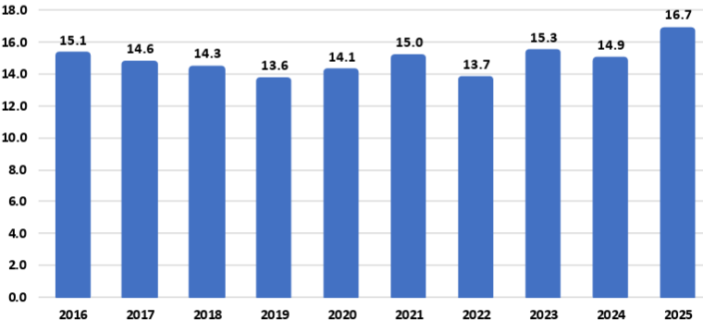
Source: USDA
For example:
The National Corn Growers Association (NCGA) is intensifying its call for action from Congress and the administration after the U.S. Department of Agriculture’s latest World Agriculture and Supply and Demand Estimates report projected a record 16.7-billion-bushel corn crop this year, further threatening the livelihood of farmers already facing record-low corn prices.
“Corn growers are already marketing their corn for extremely low corn prices, and this massive projected corn supply without market-based solutions to increasing corn demand is already causing corn prices to fall further,” said Illinois farmer and NCGA President Kenneth Hartman Jr. “Because we need markets fast for this supply, we are redoubling and intensifying our call for Congress to pass pending E15 legislation that will allow for year-round consumer access to higher blends of ethanol and for the Trump administration to quickly broker deals that will open new foreign markets for corn.”
Today’s WASDE report projects average corn yields of 188.8 bushels per acre for 2025, for an overall crop of 16.7 billion bushels. If the projections prove accurate, this year’s crop will be the largest on record by far: 1.4 billion bushels above the current production record set in 2023, a 9.1 percent increase.
An immediate boost to demand would be the passage of legislation authorizing year-round consumer access to 15 percent ethanol blend, or E15. This solution comes at no cost to consumers, requires no additional infrastructure developments and would generate demand for an additional 457 million bushels of corn, according to NCGA estimates.
NCGA is also pushing the administration to quickly broker additional deals with other countries and finalize details on deals already announced. For example, India, Vietnam and Kenya are all strategically important markets to U.S. corn growers.
Sen. Joni Ernst, R-Iowa, on July 31 introduced the Ethanol for America Act, a bill that aims to make it easier for Americans to fuel their vehicles with domestically produced E15. Companion legislation was introduced the following day by Rep. Adrian Smith, R-Neb.
The legislation would eliminate unnecessary barriers to E15 by requiring the U.S. EPA to finalize rulemaking from 2021 to make the E15 fuel label clearer and more consumer oriented. It would also confirm the compatibility of E15 with existing underground fuel storage and dispensing equipment.
Currently, fuel dispensers offering E15 must feature a label designed to alert customers to the appropriate and lawful use of the fuel. The proposed rule, issued in January 2021, co-proposes to either modify the E15 label or remove the label requirement entirely. The EPA opened a 90-day public comment period on the proposal but has failed to take final action on the rulemaking.
Following its introduction, the Senate bill, S. 2591, was referred to by the Senate Committee on Environment and Public Works. To date, Sens. Amy Klobuchar, D-Minn.; Deb Fischer, R-Neb.; Chuck Grassley, R-Iowa; Tammy Duckworth, D-Ill.; and Richard Durbin, D-Ill., have signed on to cosponsor the bill. The House bill, H.R. 4864, was referred to the House Committee on Energy and Commerce. Reps. Nikki Budzinski, D-Ill.; Dusty Johnson, R-S.D.; Tracey Mann, R-Kan.; Derek Schmidt, R-Kan.; Mike Flood, R-Neb.; Randy Feenstra, R-Iowa; and Brad Finstad, R-Minn., are cosponsoring the House bill.

Vietnam Opening Market to Ethanol
To boost ethanol imports from the U.S. tenfold to approximately 290 million gallons, the Vietnam Biofuel Association has proposed that the government swiftly implement a nationwide E10 biofuel gasoline program.
The Vietnam Biofuel Association recently submitted a document to the Domestic Market Management and Development Department (under the Ministry of Industry and Trade), addressing several issues related to the import tax on 99 percent ethanol used for biofuel blending, as well as the broader context of tariff negotiations and trade relations between Vietnam and the United States.
According to the association, the import tax on 99 percent ethanol - a type specifically used in biofuel gasoline blending - has continuously decreased from 15 percent to 12 percent, then 10 percent, and most recently to 5 percent. These reductions fall within the broader trade policy framework between Vietnam and the U.S.
Petrolimex and PVOIL, Vietnam’s two largest fuel distributors and retailers, launched the country’s first commercial trials of gasoline blended with 10 percent ethanol (E10) in three major cities last week. A total of 42 fuel stations in Hanoi, Ho Chi Minh City and Hai Phong began selling E10 RON95 gasoline as part of the trial that follows the Government of Vietnam’s recent announcement of a nationwide E10 mandate to begin in January.
“The U.S. Grains & BioProducts Council (USGBC) and its members and partners commend Petrolimex, PVOIL and the Government of Vietnam for advancing the use of fuel ethanol in Vietnam as a means to reduce harmful emissions, bolster fuel security and further stimulate rural economies,” said Ryan LeGrand, USGBC President and CEO. “This month’s rollout of E10 gasoline at retail stations is a massive step toward decarbonizing Vietnam’s transportation sector and a new potential partner for the U.S. ethanol industry and the American farmer.”
In 2018, Vietnam implemented an E5 mandate for its RON92 grade of gasoline, one of two gasoline grades widely used throughout the country. The Government of Vietnam’s decision to expand and migrate the country’s ethanol policy in 2026 to E10 and all grades of gasoline, including the more widely used RON95 grade, will help the Vietnamese fuel industry amplify the environmental and economic benefits of fuel ethanol use which augment Vietnam’s policy objectives.
Vietnam’s gasoline consumption surpassed 2.8 billion gallons in 2024, increasing 8.1 percent from 2023 consumption levels. A nationwide E10 mandate will create a total fuel ethanol demand of 280 to 300 million gallons per year, depending on gasoline demand.

USDA Land Value Report
The United States farm real estate value, a measurement of the value of all land and buildings on farms, averaged $4,350 per acre for 2025, up $180 per acre (4.3 percent) from 2024. The United States cropland value averaged $5,830 per acre, an increase of $260 per acre (4.7 percent) from the previous year. The United States pasture value averaged $1,920 per acre, an increase of $90 per acre (4.9 percent) from 2024.

Average Farm Real Estate Value (Dollars)
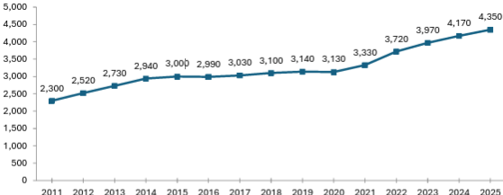
Source: USDA NASS

Farm Real Estate Value by State
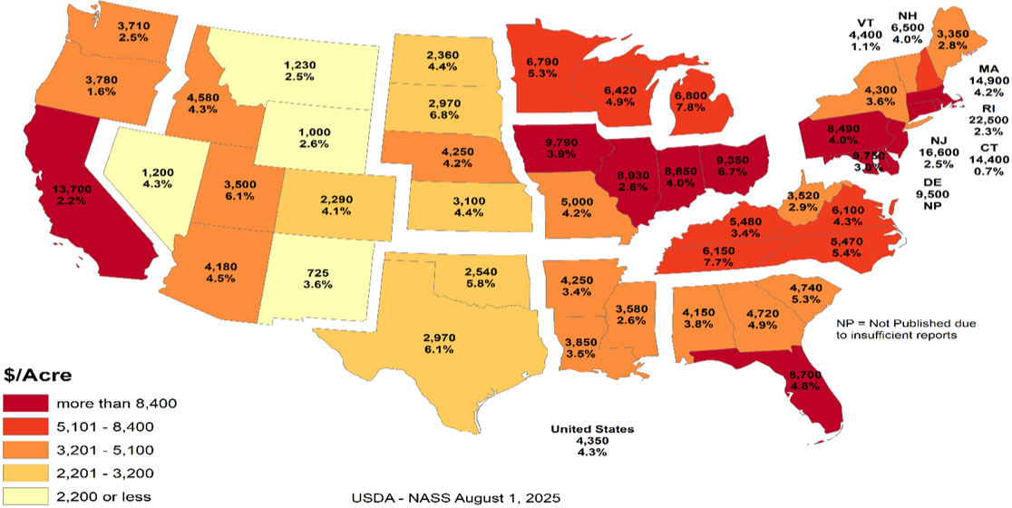
Like overall farm real estate values, average U.S. cropland values rose to record levels in 2025, reaching $5,830 per acre. This marks a 4.7 percent increase over 2024, nearly identical to the previous year’s growth but slower than the sharper increases earlier in the decade. In dollar terms, cropland values rose by $260 per acre year over year. Regional patterns remain consistent with broader farmland trends, with California and Northeastern states reporting the highest average cropland values. These are followed by much of the Midwest and Florida, the latter reflecting strong specialty crop production and ongoing residential development pressures. The top three states in percentage growth were Utah (9.7 percent), Michigan (8.2 percent) and Tennessee (7.8 percent). Notably, no states recorded a decline in cropland values.

Average Cropland Value (Dollars)
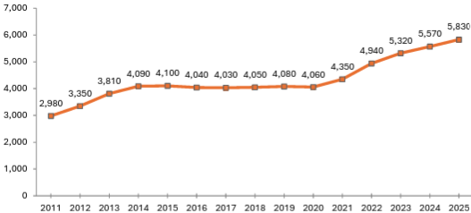
Source: USDA NASS

Cropland Value by State
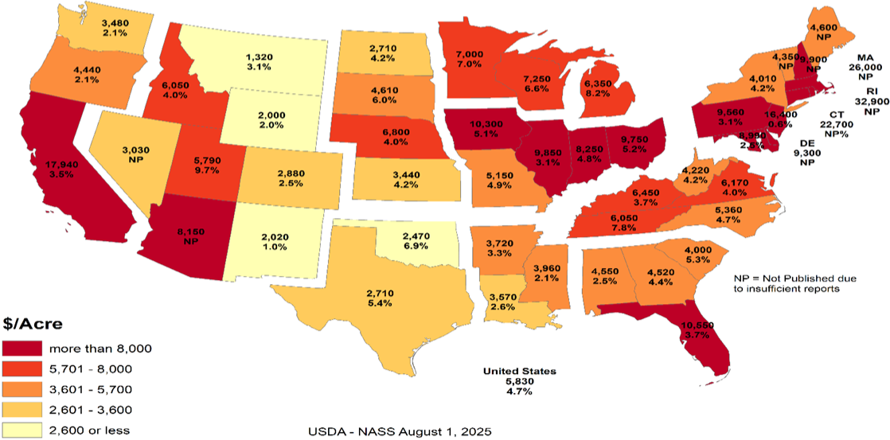
U.S. pastureland values continued their upward trend in 2025, rising to $1,920 per acre, a 5 percent increase over 2024. This growth is nearly in line with last year’s 5.2 percent gain but remains below the 6.7 percent increase in 2023 and the sharp 11 percent jump in 2022, which followed nearly a decade of stagnant values.
Unlike cropland and overall farm real estate, pastureland values are highest along the East Coast and mid-South, where development pressures, land scarcity and lifestyle demand contribute to elevated prices. In contrast, Western and Plains states report lower average values, partly due to lower land productivity and the prevalence of federally owned grazeable land accessed through grazing permits, which reduces market-based competition. In densely populated Eastern states, fragmentation of land and rising competition for open space (whether for grazing, recreation or rural living) continue to drive up per-acre costs for the limited private pastureland available.

Average Pasture Value (Dollars)
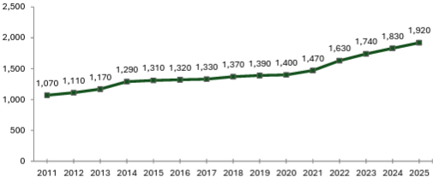
Source: USDA NASS

Pasture Value by State
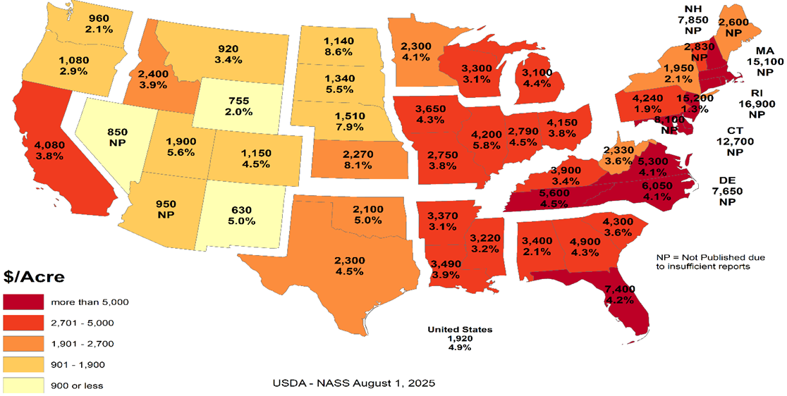

Cash Rents
American Farm Bureau summarized the USDA NASS cash rent survey.
NASS also released data on cash rents, which tend to lag changes in land values and commodity prices due to early-season lease negotiations. While the reported figures reflect past agreements, they often serve as important benchmarks for future producer-landlord negotiations, especially in areas with variable rent structures. Average U.S. cropland rent increased to $161 per acre in 2025, a modest 0.6 percent rise over 2024 — just $1 per acre. Irrigated cropland rents declined by 0.4 percent to $244 per acre, while non-irrigated rents rose 0.7 percent to $147 per acre. Pastureland cash rents remained unchanged at $15.50 per acre.
Despite minimal national movement, pressures on open land for solar development, suburban expansion and recreation continue to support rental rate growth in select areas, particularly where demand for working land is layered with lifestyle or energy investment interest. Increased telework continues to pull buyers and lessees into rural areas, intensifying local competition for land in certain high-amenity or fast-growing regions.
While earlier rent increases were tied closely to the 2021–2022 commodity price boom, today’s changes are more uneven, shaped by regional water constraints and shifting cropping patterns. In some areas, recent federal disaster assistance may have tempered pressure to renegotiate downward, even as commodity prices weaken and input costs remain high.

Cropland Cash Rent Value by State (Percent Change)
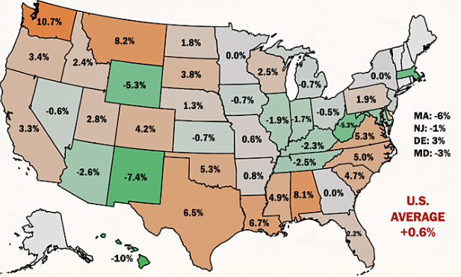
Source: American Farm Bureau, USDA NASS
Washington and Montana led the country in cropland cash rent growth, up 10.7 percent and 8.2 percent, respectively, followed by Alabama at 8.1 percent. Meanwhile, cropland rents in Hawaii, New Mexico, Wyoming, West Virginia and Massachusetts declined by more than 5 percent, likely due to a mix of stabilized drought conditions, changing land use priorities and rebalancing after years of sharp growth.
By value, the most expensive cropland rents remain in states with high-value specialty crops, such as California ($346/acre), Arizona ($334/acre) and Hawaii ($295/acre), often driven by contracts tied to irrigation infrastructure and water rights. Iowa, Illinois, Indiana and Washington round out the next tier of high-rent states, reflecting both row crop concentration and specialty crop presence. Water access and cost continue to be major drivers of both land value and rental rates across the Western U.S.
Margins for producers who rely heavily on rented land remain precarious, especially as revenue potentially slips while fixed costs (including rents) remain elevated or inflexible. Beginning farmers and those without land equity are especially exposed, facing steep barriers to accessing operating credit. In a year where net farm income is forecasted to decline without ad hoc support, even modest increases in rental rates can have outsized financial consequences.

Conclusion
Rural land values are experiencing a price bubble. In many of the Corn Belt states the cropland value continues to increase while the cash rent decreases. The values represent the impact of government land-based farm programs and ad hoc payment that could go to landowners. The government incentives to buy land have diminished the link between land values and real agricultural value. The result is farmers who rent land are increasingly in financial distress. As farmers exit the market, the disconnect between the land prices and cash rents will increase.
What the government gives it can take away. The Democrat party can win without the farm vote. Their messaging is trending away from “preserving family farmers” to “bashing Big Ag.” If rural land prices start declining, the floor is real agricultural value. For example, Illinois cash rent for cropland is $264 per acre. Farmdoc crop budget indicates that if a cash rent farmer needs $100 profit per acre to survive, the cash rent should be approximately $133 per acre or a decrease of approximately half. Assuming a 5 percent rate of return, the real agricultural value for cropland in Illinois is $2,660 per acre versus $9,850 per acre.
The other concern is that many of the new land buyers are investors. The investors are helping to drive land prices higher. When land values decrease, will the investors sit tight or take a profit? The investors do not have the same emotional attachment to the land. Farmers who want to own their own land act as a “put” under the land market. The good news is the farmers currently have low debt levels. This means the farmers have access to cash to buy land. The unknown is if the farmers are making a good investment or trying to catch a falling knife.

Cropland Cash Rent Value by State
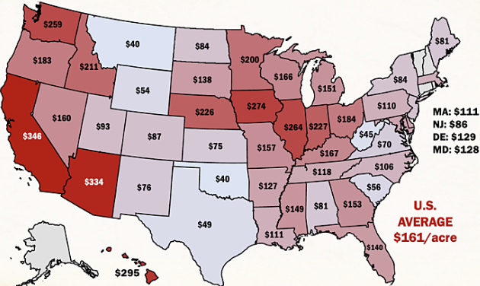
Source: American Farm Bureau, USDA NASS

Farmer Sediment
The Purdue University-CME Group Ag Economy Barometer index declined for the second month in a row. The July index fell 11 points below June’s reading and was fueled by U.S. farmers’ weaker perceptions regarding both current conditions and their expectations for the future. The July Current Conditions Index fell 17 points while the Future Expectations Index declined 7 points, both compared to a month earlier. Weaker income prospects in 2025 were largely responsible for farmers’ weaker appraisal of current conditions. Although all three principal farmer sentiment indices were lower in July than a month earlier, producer sentiment remains much more positive than at this time last year, with nearly three-quarters of July’s survey respondents reporting that the U.S. is headed “in the right direction.” The July barometer survey took place from July 7-11, 2025.
Concerns about weak income prospects in 2025 were evident in the July survey as the Farm Financial Performance Index fell 14 points compared to a month earlier. This month’s decline left the index at a reading of 90, indicating that more farmers expect weaker rather than stronger income in 2025 compared to 2024. Weakening crop prices are eroding income prospects. For example, in the Eastern Corn Belt, bids for fall harvest delivery of corn and soybeans were 7 percent and 3 percent lower during the July survey week, respectively, than just 4 weeks earlier. In turn, the decline in farmers’ income prospects helped push the Farm Capital Investment Index down 7 points in July to a reading of 53.

Farm Financial Performance Index
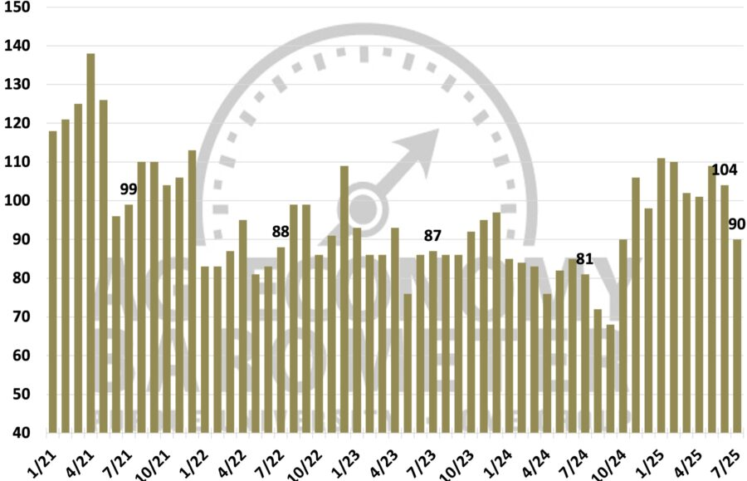
Source: Purdue/CME Group Ag Economy Barometer
Unsurprisingly, a weaker income outlook led to a softer outlook for farmland values in the upcoming year. The Short-Term Farmland Value Expectations Index dipped 5 points below a month earlier. This month’s reading of 115 also left the index 3 points lower than a year earlier and 10 points below two years ago. The farmland index’s weakness was attributable to a small shift among respondents away from expecting values to rise to looking for weakening values in the upcoming year, while the percentage expecting values to hold steady rose just one point to 57 percent. With farmland leasing discussions for next year underway between farmers and landowners, this month’s survey included a question regarding crop producers’ expectations for farmland cash rental rates in 2026. Despite weakening crop income prospects, nearly three-fourths (73 percent) of respondents said they expect cash rental rates in 2026 to remain about the same, with just 11 percent of crop producers indicating they expect rental rates to decline.
One supporting factor for both farmland values and farmland cash rental rates could be producers’ expectations regarding the farm income safety net provided by U.S. farm programs. In this month’s survey, 31 percent of respondents said they expect the safety net in the 2025 Farm Bill to be stronger than in the previous Farm Bill.
U.S. farmers in July were somewhat more optimistic about future agricultural trade prospects than a month earlier. This month, 43 percent of respondents said they expect agricultural exports to increase in the upcoming five years, up from 41 percent a month earlier. Fewer producers said they are looking for exports to decline, dropping to 13 percent of respondents, down from 16 percent who felt that way in June. In a related question, 64 percent of this month’s survey respondents said they think it likely that new foreign export markets will open to American agricultural goods in the next five years. To further gauge U.S. farmers’ outlook regarding trade and policy, this month’s survey included the following question: “Would you say things in the United States today are generally headed in the right direction or on the wrong track?” Seventy-four percent of respondents said the U.S. is headed in the “right direction.”
U.S. farmers’ sentiment declined in July as weaker farm income prospects dimmed producers’ view of current conditions and their future expectations. Despite a weaker crop income outlook, just 11 percent of crop producers said they expect farmland cash rental rates to decline, with a majority reporting that they expect rental rates to stay about the same. Helping to support producers’ farmland value and rental rate outlook is farmers’ expectation for a stronger farm income safety net, with nearly one-third (31 percent) of U.S. producers saying they expect the 2025 Farm Bill to provide a stronger safety net than the previous Farm Bill. Producers in July were somewhat more optimistic about U.S. agricultural trade prospects than in June, while nearly three-fourths (74 percent) of U.S. farmers responding to the survey reported that they feel that things in the U.S. are headed “in the right direction.”

Bunge Buys IFF Crush Division
As part of its second quarter results disclosure, International Flavors & Fragrances Inc. announced that it has entered into a definitive agreement to divest its soybean crush, concentrates, and lecithin business to Bunge Global S.A. The transaction includes operations that generated approximately $240 million in revenue in 2024 and employs around 250 people globally. The sale aligns with IFF’s strategy to strengthen its portfolio and supports the ongoing evaluation of strategic alternatives for its Food Ingredients segment, with a focus on maximizing shareholder value.

Greenhouse Gas Phase 3 Standards do not Apply to Human Health
The industry has an aftertreatment system for EPA's 2007 and 2010 Heavy-Duty Highway Engines and Vehicle emissions reduction regulations, which set standards for not only NOx but also particulate matter (PM). It also mandated the use of advanced emission control technologies like selective catalytic reduction (SCR) and diesel particulate filters. "Completely separate," said North American Council for Freight Efficiency Executive Director Mike Roeth. "Aftertreatment is not a direct GHG solution. We tend to call NOx and PM pollutant emissions, and they are directly attached to human health; breathing in these in the air... Carbon/GHG is different in that it affects climate, encouraging our more frequent and harsher weather events causing other health concerns."
Daimler Truck North America (DTNA) noted in a statement to Commercial Carrier Journal (CCJ) that the proposal does not modify EPA's existing requirements for criteria pollutants, including NOx and PM. NOx and PM standards remain in place, and they continue to be enforced independently of any changes to GHG regulations. "Selective Catalytic Reduction (SCR) systems, Diesel Exhaust Fluid (DEF), and aftertreatment technologies are essential components designed to reduce nitrogen oxides (NOx) regulated under the EPA's Clean Air Act," added Paccar companies Kenworth and Peterbilt. "The current aftertreatment systems related to NOx are still required to meet EPA and CARB standards and are independent of greenhouse gas (GHG) specific mandates."
Covered in the Endangerment Finding is nitrous oxide (N2O). NOx is shorthand for nitric oxide (NO) and nitrogen dioxide (NO2), the nitrogen oxides most relevant for air pollution. NOx itself is not considered a greenhouse gas; rather it plays a role in the formation of ozone, a naturally occurring greenhouse gas. Thus, NOx is not a greenhouse gas and the aftertreatment system, including DEF, would not be affected by this pending regulatory change.
However, EPA Administrator Lee Zeldin said in March his office intends to revisit portions of the Biden-era Clean Trucks Plan, which includes the 2022 Heavy-Duty NOx rule – a standard that includes new, more stringent emissions standards that cover a wider range of heavy-duty engine operating conditions and requires these more stringent emissions standards to be met for a longer period of time.

DEF Guidance Clarification
Starting in the early 2010s, regulations required all new on-road diesel vehicles, tractors, trucks, buses, ships, locomotives, gas turbines and construction equipment, to install additional technology to reduce nitrogen oxide emissions, a byproduct of diesel. Almost all commercial diesel transportation and equipment today has Selective Catalytic Reduction (SCR) technology that runs on DEF.
According to an EPA release, "EPA issued clear guidance urging engine and equipment manufacturers to revise DEF system software in existing vehicles and equipment to prevent these sudden shutdowns, giving operators more time to repair faults without impacting productivity or safety."
The EPA provided a chart showing derate timing for heavy duty trucks will be extended from a 5-mph limitation after just four hours' worth of a system fault to a three-stage derate:
- 15 percent torque reduction at 650 miles / 10 hours
- 30 percent torque reduction then at 4,200 miles / 80 hours
- and a final-stage derate to 25 mph at 8,400 miles / 160 hours
"In addition to providing certainty to manufacturers about how EPA wants this issue resolved, the agency is not requiring separate approvals beyond that provided in EPA’s guidance," the release said. "This ensures that bureaucratic steps do not delay manufacturers’ ability to put solutions into the field.”
Before the new EPA DEF guidance, a farmer had four hours before the vehicle or equipment stopped operating, leaving the farmer stranded. EPA’s new guidance to engine manufacturers will reduce derating, an automatic trigger forcing the engine to operate at a reduced capacity far below its capability and increase the amount of time operators must secure DEF and refuel.
Previously, farmers and truckers faced rapid engine slowdown to 5 mph within just four hours of a sensor alert. Under EPA’s new guidance for heavy-duty trucks, for example, after a fault is detected, only a warning light appears for 650 miles or 10 hours. Most significantly, there is no performance impact for at least one workday. Then, the engine only mildly derates by 15 percent, but this does not limit speed, allowing trucks to operate normally for up to 4,200 miles or two work weeks. Only after about four work weeks does speed drop to 25 mph until repairs are made. Most operators are expected to fix issues well before reaching this limit. Moving forward for farmers, non-road equipment will not experience an impact for the first 36 hours.
The ruling represents a major step up from the status quo by giving operators significantly more time to address faults before experiencing severe engine or speed limitations, which will improve their ability to complete daily operations and reduce downtime.
The revised DEF guidance is estimated to reduce farming expenses by $727 million annually. With fewer disruptions, reduced costs for emergency towing, repairs, rentals, DEF deliveries and inventories, producers will have greater operational and financial control.

Truck Manufacturers Sue CARB/California
Four of America’s top truck makers have officially filed a lawsuit in the U.S. District Court for the Eastern District of California challenging the Clean Truck Partnership (CTP) agreement signed with the California Air Resources Board in 2023. CARB has argued since the Congressional rollback of its Advanced Clean Trucks and Omnibus Low-NOx rules earlier this summer that despite the federal disapproval of the regulations, the CTP is still binding.
Cummins, Daimler Trucks North America, Hino, Isuzu, then-Navistar, Paccar, the Truck and Engine Manufacturers Association, and Volvo Group North America in July 2023 were among 11 signers of the CTP, an agreement with CARB that pledged truck and engine manufacturers will meet California’s vehicle standards and required the sale and adoption of zero-emission vehicle (ZEV) technology.
The OEMs said in the lawsuit that despite the Congressional Review Acts passed this year preempting California’s emissions standards, the state “continues to demand compliance with its heavy-duty emissions standards, and it has threatened OEMs that design, develop, manufacture and sell heavy-duty vehicles and engines ... with civil sanctions and unfavorable regulatory treatment if the OEMs refuse to comply with the state’s unlawful standards, while also taking measures to insulate itself from lawful challenges to those standards.”
Senior Clean Vehicles Advocate for the Natural Resources Defense Council Guillermo Ortiz called the lawsuit, "a cynical reversal of course. These companies helped negotiate the Clean Truck Partnership to secure regulatory certainty. Now they’re trying to dismantle the very deal they shaped -- injecting instability into a market they claim to lead," he said. "This is bad faith, plain and simple, and it raises questions about whether these manufacturers are serious about their ability to deliver clean trucks to the global stage."
The OEMs said the U.S. Department of Justice has sent them Cease & Desist letters stating that California’s enforcement of its regulations “is contrary to federal law” and directed the truck makers “to immediately cease and desist compliance with California’s preempted and unlawful mandates.”
This has left the OEMs “caught in the crossfire,” they said, as “California demands that OEMs follow preempted laws; the United States maintains such laws are illegal and orders OEMs to disregard them. This situation is not tenable.”
As such, the lawsuit aims to clarify the OEMs’ legal obligations under federal and state law and to block California from enforcing regulations that are preempted by federal law. Given the inconsistencies between federal and California regulatory requirements for emissions, truck and engine makers and their trade associations in 2023 petitioned CARB for relief from the state’s “infeasible regulatory requirements,” which resulted in the CTP, the lawsuit added. Now, according to the OEMs, “California seeks to use the Clean Truck Partnership, which was intended to harmonize compliance with state and federal law, to compel an entire industry to follow California emissions standards that are now in conflict with federal law, and which have been expressly preempted by federal law.” They added that the state is disregarding the CTP’s “plain language,” which “states that manufacturers are obligated to follow CARB’s emissions regulations ‘regardless of the outcome of any litigation challenging … those regulations, or CARB’s overall authority to implement those regulations,’ not federal legislative action taken to invalidate them.”
The regulatory back-and-forth between the federal government and California/CARB has put OEMs “in an impossible position,” they said in the lawsuit. “As a result, the OEMs are subject to two sovereigns whose regulatory requirements are irreconcilable and who are openly hostile to one another. Each wields a hammer to enforce its will on industry, leaving OEMs -- who simply seek to sell heavy-duty trucks in compliance with the law -- unable to plan with the necessary certainty and clarity where their products need to be certified for sale and by which regulatory authority.”
California, citing the CTP, has contended that in order for OEMs to legally sell trucks in the state, they must obtain certification from CARB. Yet the OEMs said this process “takes months,” adding that they “need to know within a matter of weeks whether they must obtain a model year 2026 certification from CARB in order to lawfully sell their products in California and other opt-in states, which together represent approximately 25 percent of the national market for new vehicle registrations for heavy-duty vehicles.”
In filing the lawsuit, the truck makers said they are looking for “declaratory and injunctive relief with the goal of clarifying and establishing the regulatory obligations that they must follow to lawfully offer products for sale in California and the various opt-in states, and to prevent California officials from violating their constitutional rights,” adding that “an expeditious decision is essential.”
The OEMs’ lawsuit joins another suit brought by the Western States Trucking Association that challenged CARB’s authority to enforce the CTP following the federal preemption of the regulations.

Ambassador Jamieson Greer: Why We Remade the Global Order
The following op-ed provides the foreign policy vision of the Trump Administration. On the 200-day mark of the second Trump administration, United States Trade Representative Jamieson Greer published an op-ed in The New York Times explaining how President Trump’s trade policy is remaking the international economic order to reduce our trade deficit and deliver lasting benefits for American workers and industries.
The full text of the op-ed is below:
It must be an unwritten rule that international economic orders emerge at stately hotels. In 1944, as World War II raged, Allied representatives gathered at a picturesque New Hampshire resort named Bretton Woods to discuss how to establish a postwar economic order to restore the sensible flow of trade in a fractured world.
Although the resulting Bretton Woods system ended in 1976, its legacy lives on. Our current, nameless global order, which is dominated by the World Trade Organization and is notionally designed to pursue economic efficiency and regulate the trade policies of its 166 member countries, is untenable and unsustainable. The United States has paid for the system with the loss of industrial jobs and economic security, other countries have been unable to make needed reforms, and the biggest winner has been China, with its state-owned enterprises and five-year plans. Unsurprisingly, the past decade has seen significant international and bipartisan American frustration at the system’s failure to adapt to meet the essential interests of sovereign nations.
Now, reform is at hand. Last week at his Turnberry resort on the Scottish coast, President Trump and the European Commission president, Ursula von der Leyen, concluded a historic agreement — one that is fair, balanced and oriented toward serving concrete national interests rather than vague aspirations of multilateral institutions. Indeed, by using a mix of tariffs and deals for foreign market access and investment, the United States has laid the foundation for a new global trading order.
The previous system rejected tariffs as a legitimate tool of public policy, meaning that the United States sacrificed tariff protection for critical manufacturing and other sectors. Over the past three decades, the United States slashed barriers to our market to allow vast inflows of foreign goods, services, labor and capital. At the same time, other countries kept their markets closed to our goods and deployed a suite of policies — such as subsidies, wage suppression, lax labor and environmental standards, regulatory distortions and currency manipulation — to artificially boost exports to the United States. This approach made the United States and a handful of other economies the consumers of last resort for countries pursuing beggar-thy-neighbor economic policies.
Our trading partners were adept at this game, and elites on Wall Street and in Washington were all too happy to cash in on the global arbitrage by moving production abroad. The net result? The bulk of global manufacturing shifted to jurisdictions such as China, Vietnam and Mexico where companies could exploit vulnerable workers or benefit from expansive state support while the United States ran up what in absolute terms is the highest trade deficit in the history of the world. This led to extensive and well-documented losses in U.S. industrial capacity and employment as well as reliance on our adversaries for critical supply chains.
We subordinated our country’s economic and national security imperatives to a lowest common denominator of global consensus. This approach harmed American workers, their families and communities by undermining a manufacturing sector that creates high-wage jobs, fosters innovation and catalyzes investment across the economy.
What began at Bretton Woods as a necessary effort to rebuild a global trade system shattered by war evolved, over nine rounds of trade negotiations, into something unrecognizable. The measured guidelines for commerce developed in the Kennedy and Tokyo Rounds gave way to our recent experiment in global hyper-integration, embodied in the Uruguay Round, which concluded in 1994 and established the W.T.O.
We are now witnessing the Trump Round. On April 2, President Trump announced tariffs to address the national emergency posed by the trade deficit. The intense bilateral negotiations that followed were held in diverse locations across the world: Washington, Geneva, Jeju Island, Paris, London, Stockholm and, of course, Turnberry. Our trading partners had never before shown such interest in opening their markets to the United States, aligning on matters of economic and national security, and rebalancing trade in a more sustainable direction. In a few short months, the United States secured more foreign market access than it had in years of fruitless W.T.O negotiations.
Reversing decades of harmful policy that weakened our manufacturing capacity and work force will take time and coordinated effort across the public and private sectors. But keeping the status quo would only accelerate the dangerous trajectory of deindustrialization. We require a generational project to re-industrialize America, and time is short.
When I joined a critical mass of my fellow trade ministers in June at a meeting of the Organization for Economic Cooperation and Development in Paris, I was struck by how many voiced serious concerns about the danger of macroeconomic imbalances, the threat of nonmarket practices and the sclerotic state of the global trading system — the same issues President Trump has raised for years and now taken emergency action to address. What was long dismissed as heresy by the free-trade fundamentalists in Brussels, Geneva and Washington is now becoming conventional wisdom.
In announcing the U.S.-European Union deal last week, President von der Leyen echoed the call to refashion global trade to adapt to economic and political realities. She explained to reporters that the trans-Atlantic economic relationship needed “rebalancing” to ensure that it could be “more sustainable.” Such recognition is reinforced by additional deals with Britain, Cambodia, Indonesia, Japan, Malaysia, Pakistan, the Philippines, South Korea, Thailand and Vietnam, which make up almost 40 percent of U.S. trade, according to my office’s figures. Other countries with large trade surpluses with the United States are subject to generally higher tariffs. The new economic order, solidified at Turnberry, is emerging in real time.
The results are astounding. Every year for 40 years, the Office of the U.S. Trade Representative has produced a detailed report called the National Trade Estimate chronicling various barriers faced by U.S. companies, including high tariffs, requirements to produce goods in the countries where the companies want to do business, and restrictions on agricultural products contrary to scientific consensus. In the past, the only significant way the United States could remove these barriers (if at all) was by giving away the tariffs defending our manufacturing sector. President Trump has flipped the script on this: Now, we are systematically eliminating these barriers abroad while ensuring sufficient tariff protection at home.
Indonesia is lowering 99.3 percent of its tariffs on imports from the United States and eliminating a slew of longstanding non-tariff barriers, while accepting a 19 percent tariff on exports to the United States. South Korea is accepting U.S. auto standards along with a 15 percent tariff. Vietnam pledged to lower all of its tariffs and barriers in exchange for a 20 percent rate. Most countries we are negotiating with have also agreed to cooperate on economic security to ensure the safety and reliability of our critical supply chains.
Countries are also committing to upgrade and better enforce their labor standards, tackling arbitrages that have put American workers and producers at a disadvantage. Multiple countries will join the United States (along with the E.U., Mexico and Canada) in banning the importation of goods made with forced labor. Eliminating global slavery was a longstanding goal of advocates and policymakers, but it was the leverage of President Trump’s tariffs that finally made it possible to unlock meaningful progress.
Similarly, countries are agreeing to improve resource efficiency and enforcement of environmental laws, including in the most problematic sectors, such as illegal logging, illegal fishing and the illegal wildlife trade. The international trade system should not force Americans to compete with those who use our responsible capitalism against us as a competitive advantage.
Importantly, these commitments are actionable, and the United States will enforce them. Rather than the drawn-out dispute settlement process favored by the old guard of trade bureaucrats, the new U.S. approach is to closely monitor implementation of the deals and swiftly reimpose a higher tariff rate for noncompliance if needed. President Trump uniquely recognizes that the privilege of selling into the world’s most lucrative consumer market is a mighty carrot. And a tariff is a formidable stick.
At the World Trade Organization, enacting changes to trade rules requires total consensus among nations. In fact, the last attempt at serious reform, known as the Doha Round, failed because protectionist nations refused to take down their trade barriers to the United States. Moreover, our adversaries relish blocking reform. They prefer a status quo that feeds an exploding U.S. trade deficit, sapping this nation of the industrial might that made it, and keeps it, a superpower.
But the rules of international trade cannot be a suicide pact. By imposing tariffs to rebalance the trade deficit and negotiating significant reforms that form the basis of a new international system, the United States has shown bold leadership to address what policymakers long considered intractable problems.
Many of these deals also come with significant investment commitments into U.S. productive capacity, such as $600 billion in the case of the European Union and $350 billion by South Korea. These investments — 10 times larger than the inflation-adjusted value of the Marshall Plan that rebuilt Europe after World War II — will accelerate U.S. reindustrialization. South Korea will help reinvigorate the American shipbuilding industry, which has atrophied in the face of nonmarket competition. These types of investments are on top of purchase commitments that cumulatively account for almost $1 trillion of American energy, agriculture, defense and industrial products. This demand for American goods and ready access to capital will allow American manufacturing to reassert leadership across strategic sectors where we have fallen behind.
Skeptics point out that tariffs, although once a fixture of American economic policy, have not been used this extensively for generations. But we now have data showing that the failure to use tariffs or similar protections created an economy that was heavy on finance and consulting fees and low on the lasting wealth and security that come from making things. Even among those who agree with that diagnosis, some say the president’s remedy is too strong or was administered too hastily, or that the tariffs will be too disruptive in the short term. This is not the time to debate how many angels can dance on the head of a pin. This is an emergency. We know what the problem is and we know how to address it. There is no time to waste.
President Trump has already shown that he can implement tariffs and other economic tools to reshape supply chains and reinvigorate manufacturing. When he deployed sweeping tariffs in his first term, not only did the sky not fall as pundits predicted, but inflation actually went down. And now that he is imposing tariffs even more broadly, inflation remains in check. A long-term problem won’t be fixed overnight, and the process may not always be smooth, but the situation demands strong and resolute action to strengthen the U.S. industrial base.
It took over 50 years from that first meeting at Bretton Woods until the creation of the W.T.O. It has been 30 years since. Fewer than 130 days from the beginning of the Trump Round, the Turnberry system is by no means complete, but its construction is well underway.

Stagflation Discussion
Stagflation talk has taken center stage. It should be remembered that stagflation in the 1970s was driven by crude oil prices increasing from $3.56 per barrel in August 1973 to $10.11 per barrel in January 1974 to $14.85 per barrel in January 1979 to $39.50 per barrel in May 1980. In less than seven years crude oil price increased by over 1,100 percent. By comparison, the current crude oil price is approximately half the May 2022 price. With almost every country expanding energy production, lower energy prices could occur.
According to the prolonged price decrease in crude oil and natural gas, inflation numbers will be below macro-economic models. This is because energy is incredibly important as it impacts inflation numbers directly, such as fuel and as a feedstock in petrochemicals, and indirectly, such as an increased cost that a manufacturer and business must recoup. Energy costs impact input prices for production, and every other stage required to reach the consumer with each cost increase being pushed to the next level. The cumulative impact of higher energy prices on the consumer tends to be understated by macro-economic models.
One inflationary outcome from lower energy prices is discretionary income increasing, which allows for more spending. The other outcome is the producer price index will show a decline with retail sales prices staying firm and retailers performing better than if it was still a higher energy cost environment. Any economic downturn will force retailers to lower prices to move products.
The inflationary impact of the massive increase in the money supply has worked its way through the economy, resulting in a natural slowdown. It is difficult to have runaway inflation with lower energy prices, and a weak housing market.
During the last trade war, the rate of inflation decreased. It is not a forgone conclusion that the rate of inflation is going to increase. The consumer price index increased a seasonally adjusted 0.2 percent for the month and 2.7 percent on a 12-month basis, the Bureau of Labor Statistics reported. That compared with the respective Dow Jones estimates for 0.2 percent and 2.8 percent.
Excluding food and energy, the core CPI increased 0.3 percent for the month and 3.1 percent from a year ago, compared with the forecasts for 0.3 percent and 3 percent. Federal Reserve officials generally consider core inflation to be a better reading for longer-term trends. The monthly core rate was the biggest increase since January while the annual rate was the highest since February.
Tariff-sensitive new vehicle prices also were unchanged. For now, automakers are choosing to keep market share.
A 0.2 percent increase in shelter costs drove much of the rise in the index, while food prices were flat and energy fell 1.1 percent, the BLS said. U.S. housing market now 508,715 more home sellers than homebuyers. With the current housing market experiencing pain, it is easier to envision lower prices not higher prices.

U.S. Consumer Price Index (Annual Change)
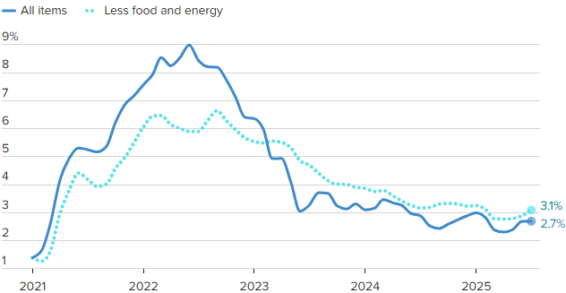
Crude Oil $120 per barrel
Source: BLS, CNBC

Estimated Number of Homebuyers and Sellers
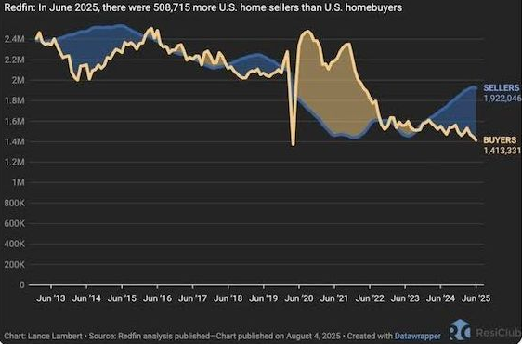

Mid-America Manufacturing Slumps for July
After six straight months of above growth neutral readings, the Creighton University Mid-America Business Conditions Index, a leading economic indicator for the nine-state region stretching from Minnesota to Arkansas, sank below 50.0 growth neutral threshold for July.

Overall Index
The Business Conditions Index, which uses the identical methodology as the national Institute for Supply Management (ISM) and ranges between 0 and 100 with 50.0 representing growth neutral, declined to 49.4 for July from 50.7 in June.
“Creighton’s latest survey continues to reflect job losses across the region, accompanied by elevated wholesale inflation,” said Ernie Goss, PhD, Director of Creighton University’s Economic Forecasting Group and the Jack A. MacAllister Chair in Regional Economics in the Heider College of Business. “Supply managers expressed growing concern that rising tariffs could further accelerate inflationary pressures. Despite these concerns, only 6.7 percent of surveyed supply managers reported shifting purchases from international to domestic suppliers in response to the tariffs.”

Employment
The July employment index fell to 45.4 from 49.4 in June, marking the fourth consecutive month below the growth-neutral threshold of 50. This sustained weakness reflects ongoing labor market challenges in the regional manufacturing sector.
“The Creighton survey has now recorded six straight months of job losses across the nine-state Mid-America region,” said Goss. “While employment rose in the first quarter—driven by increased production ahead of anticipated tariff impacts—the last four months have signaled a return to regional manufacturing job declines,” said Goss.
U.S. Bureau of Labor Statistics data show that the region shed 12,900 (-0.9 percent) manufacturing jobs over the past 12 months. The U.S. lost 89,000 (-0.7 percent) manufacturing jobs over the same time period.
Comments from Supply Managers in July:
- “Most of the suppliers I work with are dropping their production down to four-day work weeks. Nothing like a 20 percent cut in pay.”
- “I believe that the President's tariff changes are going to help our country to be better trading partners. It will take a bit of time for it all to shake out though.”
- “No changes to international purchases until a final tariff rate is in place. Certain products have been put on hold.”
- “We are not accepting pricing increases and have any tariffs added as a surcharge, so they are easy to remove.”
- “Long-term contracts have been key to holding pricing steady. Where there are extreme cost pressures with suppliers, collaboration on a resolution is the method of choice, while rare.”
- “While the Trump administration is doing everything possible to bring the economy back to its former glory, the democrats continue their seditious acts to block any attempts at dismantling their previous criminal maneuvers to destroy this great country! A reckoning is coming.”

Wholesale Prices
The July price gauge climbed to 69.7 from 67.9 in June. “The regional inflation yardstick has moved into a range indicating that inflationary pressures are moving higher at the wholesale level. However, due to a slowing regional and U.S. economies, I expect the Federal Reserve to cut interest rates at its September 16-17 meetings,” said Goss.
On average, supply managers expect tariffs to push input prices up by 7.8 percent over the next 12 months. This is up from 7.5 percent recorded in June.

Confidence
Looking ahead at the next six months, economic optimism, as captured by the July Business Confidence Index, dropped to 42.6 from June’s 50.0. “Concerns regarding tariffs and slowing new orders pushed supply managers’ expectations lower. Only one in six supply managers expect rising economic conditions for their firm over the next six months,” said Goss.

Inventories
The regional inventory index, reflecting levels of raw materials and supplies, increased to 49.1 in July from June’s 46.9. “Rapid expansions in inventories in the first quarter are now being offset by monthly pullbacks in buildups,” said Goss.

Trade
Recent uncertainty regarding tariffs and trade restrictions pushed new export orders lower for the last four months. New export orders slumped to 38.3 from 43.4 in June. As a result of record imports for the first two months of 2025, supply managers pulled back on purchasing from abroad in the last five months. The July import index increased to a still weak reading of 36.3 from 30.0 in June.
Supply managers were asked about their firm’s reactions to tariffs and threats of tariffs. Only 6.7 percent of manufacturing supply managers reported switching from international suppliers to domestic suppliers. More than one-third, or 67.0 percent, reported making no changes of suppliers due to tariffs. The remaining 26.3 percent indicated that their firms had switched from one international supplier to another international input supplier.
According to U.S. International Trade Administration (ITA) data, the regional economy exported $38.9 billion in manufactured goods for the first five months of 2025, compared to $40.8 billion for the same period in 2024, for a 4.7 percent decline. In terms of export gainers, North Dakota registered the top percentage gain with a 42.6 percent addition, and South Dakota recorded the largest percentage loss with a 19.9 percent reduction in the export of manufactured goods.

Other Survey Components of the July Business Conditions Inde
New orders dropped to 45.5 from 52.4 in June; the production or sales index increased slightly to 49.0 from 48.5 in June; and the speed of deliveries of raw materials and supplies rose to 57.8 from June’s 56.5. Higher readings indicate slower deliveries and/or rising supply chain disruptions or delays.

Arkansas
The state’s July Business Conditions Index fell to 43.0 from 48.2 in June. Components from the July survey of supply managers were new orders at 43.7, production or sales at 47.0; delivery lead time at 53.1; inventories at 39.5; and employment at 31.8. According to ITA data, the Arkansas manufacturing sector exported $2.3 billion in goods for the first five months of 2025, compared to $2.4 billion for the same period in 2024, for a 5.6 percent decline.

Iowa
The state’s Business Conditions Index for July declined to 43.7 from 48.0 in June. Components of the overall July index were new orders at 43.9; production or sales at 47.3; delivery lead time at 53.6; employment at 33.2; and inventories at 40.6. According to ITA data, the Iowa manufacturing sector exported $6.2 billion in goods for the first five months of 2025, compared to $6.9 billion for the same period in 2024, for a 10.3 percent decline.

Kansas
The Kansas Business Conditions Index for July increased to 51.1 from 49.9 in June. Components of the leading economic indicators from the monthly survey of supply managers for July were new orders at 45.5; production or sales at 50.3; delivery lead time at 58.6; employment at 47.7; and inventories at 58.6. According to ITA data, the Kansas manufacturing sector exported $5.0 billion in goods for the first five months of 2025, compared to $5.2 billion for the same period in 2024, for a 3.5 percent decline.

Minnesota
The July Business Conditions Index for Minnesota dropped to 49.3 from 52.8 in June. Components of the overall July index were new orders at 45.1; production or sales at 49.8; delivery lead time at 57.5; inventories at 50.2; and employment at 44.3. According to ITA data, the Minnesota manufacturing sector exported $9.5 billion in goods for the first five months of 2025, compared to $10.7 billion for the same period in 2024, for an 11.4 percent decline.

Missouri
The state’s July Business Conditions Index rose to 51.8 from 50.8 in June. Components of the overall index from the survey of supply managers for July were new orders at 45.6; production or sales at 50.6; delivery lead time at 59.1; inventories at 54.4; and employment at 49.2. According to ITA data, the Missouri manufacturing sector exported $7.0 billion in goods for the first five months of 2025, compared to $7.1 billion for the same period in 2024, for a 0.5 percent decline.

Nebraska
The state’s July Business Conditions Index climbed to 51.6 from June’s 51.3. Components of the index from the monthly survey of supply managers for July were new orders at 45.5; production or sales at 50.4; delivery lead time at 58.8; inventories at 53.6; and employment at 48.3. According to ITA data, the Nebraska manufacturing sector exported $2.7 billion in goods for the first five months of 2025, compared to $3.1 billion for the same period in 2024, for a 10.8 percent decline.

North Dakota
The state’s Business Conditions Index advanced above growth neutral for a 13th consecutive month to 52.2 from 52.0 in June. Components of the overall index for July were new orders at 45.7; production or sales at 50.8; delivery lead time at 59.4; employment at 50.0; and inventories at 55.0. According to ITA data, the North Dakota manufacturing sector exported $2.5 billion in goods for the first five months of 2025, compared to $1.8 billion for the same period in 2024, for a 42.6 percent gain.

Oklahoma
The state’s Business Conditions Index for July declined to 49.0 from 50.6 in June. Components of the overall July index were new orders at 45.0; production or sales at 49.5; delivery lead time at 57.2; inventories at 49.7; and employment at 43.7. According to ITA data, the Oklahoma manufacturing sector exported $2.9 billion in goods for the first five months of 2025, compared to $2.6 billion for the same period in 2024, for a 3.5 percent gain.

South Dakota
The July Business Conditions Index for South Dakota slumped to 44.5 from 48.5 in June. Components of the overall July index were new orders at 44.1; production or sales at 47.6; delivery lead time at 54.1; inventories at 42.1; and employment at 34.8. According to ITA data, the South Dakota manufacturing sector exported $0.7 billion in goods for the first five months of 2025, compared to $0.9 billion for the same period in 2024, for a 19.9 percent decline.

Corn
Fundamental Recommendation: Corn has traded to the upper end of the recent range due to early concerns about Brazilian growing conditions. However, the decline in the Chinese hog slaughter and its impact on world import demand combined with a trendline world crop will begin to build stocks – sell any contract above $4.75 unless the President’s trip to China yields a surprise agreement on corn.

Fundamental Bullish Factor – Domestic ethanol corn demand stays historically high, up by an average of three percent from last year over the last three weeks and eight percent from the five-year average for the same period.
Fundamental Bullish Factor – Beef prices remain near record levels, driving a slow reversal of the long-run cattle cycle and raising expectations for future beef demand.
Fundamental Bearish Factor – Ample to burdensome world supplies provide sufficient supply to meet demand, capping rallies
Fundamental Bearish Factor – Bearish export headlines, Brazil more competitive, China imports down
Fundamental Swing Factor – Potential delays in Brazilian soybean planting can impact the safrinha corn crop, planted in late spring
Fundamental Swing Factor – Any substantial change in world energy prices due to Ukrainian war policy as the world considers a new round of sanctions on Russian energy

Technical Recommendation: Sideways to Lower.

Technical Bullish Factor – Relative strength index is oversold and at levels that have indicated price bottoms in the past.
Technical Bullish Factor – Solid chart support just below present prices.
Technical Bullish Factor – Massive crop overwhelming technicals.
Technical Bearish Factor – Prices still in downtrend in place on daily bar chart.
Technical Bearish Factor – Prices well below key 40-day moving average.
Technical Bearish Factor – Longer-term price charts are bearish.

Corn (continued)

CBOT Corn Technicals
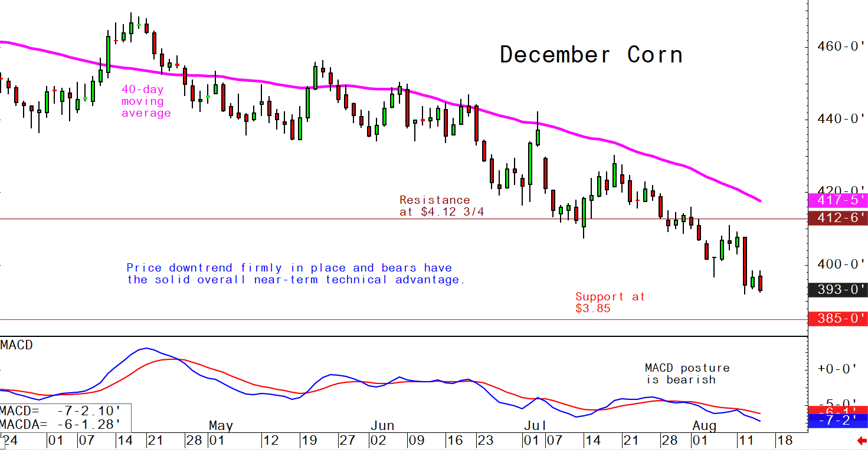
Wheat
Fundamental Recommendation: Like corn wheat is heading into a period when the market typically adds weather risk premium and the dryness in key US growing regions could justify a larger-than-normal addition heading into the 2026 growing season. However, fundamentally, ample to almost burdensome world supply balances against the potential for weather issues. So, short-term headline risk remains two tailed, but our expectation is that prices will be lower a year from now. That said, in the short-term weather headline risk could push prices higher into the winter. Given our expectations, buying small delta calls and puts would express an expectation for an increase in volatility, or the potential for significantly higher or lower prices.

Fundamental Bullish Factor – Rain delays are slowing winter wheat planting in Kansas.
Fundamental Bullish Factor – Dryness has also expanded in the high-protein growing areas of the US, supporting protein premiums.
Fundamental Bearish Factor – IGC increased world output estimates in late October
Fundamental Bearish Factor – Exporting countries expected to produce record crops in 2025/26, amplifying the ample world supply.
Fundamental Swing Factor – The Global Grains conference will bring a round of fresh supply and demand presentations and potential shift in expectations from a substantial portion of the Black Sea grain industry.
Fundamental Swing Factor – Peak La Nina could drive changing weather patterns, potentially drying down Australia and Argentina, but this remains low probability.

Technical Recommendation: Sideways to Lower.

Technical Bullish Factor – Markets are short-term oversold and due for upside correction.
Technical Bearish Factor – SRW and HRW prices well below key 40-day moving averages.
Technical Bearish Factor – SRW and HRW prices in downtrends on daily charts.
Technical Bearish Factor – Down-trending corn market is bearish for wheat.

Wheat (continued)

CBOT Wheat Technicals
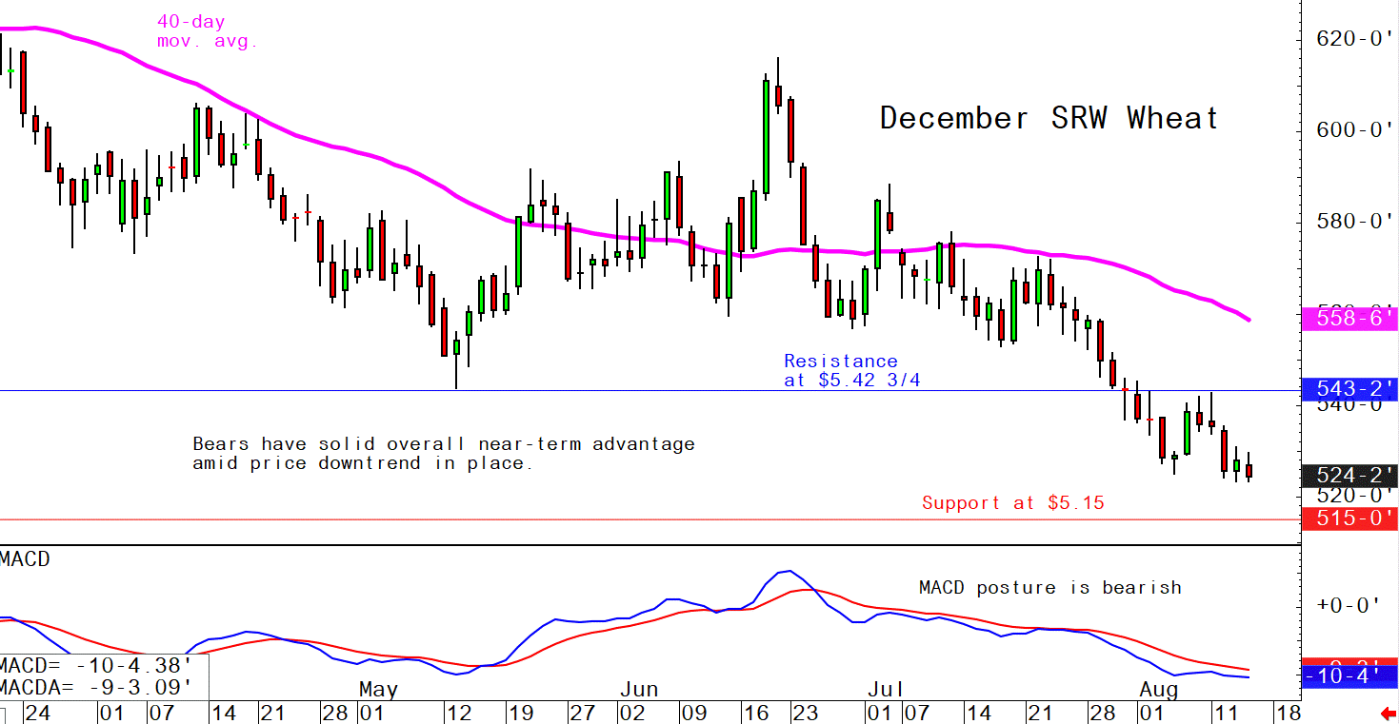

Soybeans
Fundamental Recommendation: Our initial reaction to the Chinese announcement is “trust but verify” on the performance against the contract. Analysts estimate Chinese buyers followed through on roughly three-quarters of the commitments made under the “Phase One” deal and Chinese hog economics have deteriorated due to the tariffs imposed by the Trump Administration, cutting Chinese import demand. However, the deal is only likely to impact US basis levels as the US commitments will offset purchases from Brazilian sources, allowing those exporters to backfill the customers that the US loses because it is shipping to China. We still believe the SA crop is the key driver of prices going forward and improving conditions will drive prices lower. However, given the freshness of the news, we are not as comfortable putting out a precise target this week but will work through the analysis and have an updated price forecast and specific recommendations next week.

Fundamental Bullish Factor – Resumption of Chinese purchases will support basis not flat price
Fundamental Bullish Factor – Borad crush margins seem to have stabilized around $1.50 per bushel,
Fundamental Bearish Factor – Chinese import demand has slowed due to deterioration in hog profitability
Fundamental Bearish Factor – Increased rainfall forecast for Mato Grosso
Fundamental Swing Factor – The development of La Nina
Fundamental Swing Factor – Potential decline in Chinese pork production could limit world soybean demand.

Technical Recommendation: Sideways.

Technical Bullish Factor – Prices now above key 40-day moving average.
Technical Bullish Factor – Soybean meal market now performing much better.
Technical Bullish Factor – MACD indicator turns bullish.
Technical Bearish Factor – Slumping corn and wheat markets are bearish for beans.
Technical Bearish Factor – Longer-term charts are not friendly for beans.

Soybeans (continued)

CBOT Soybeans Technicals
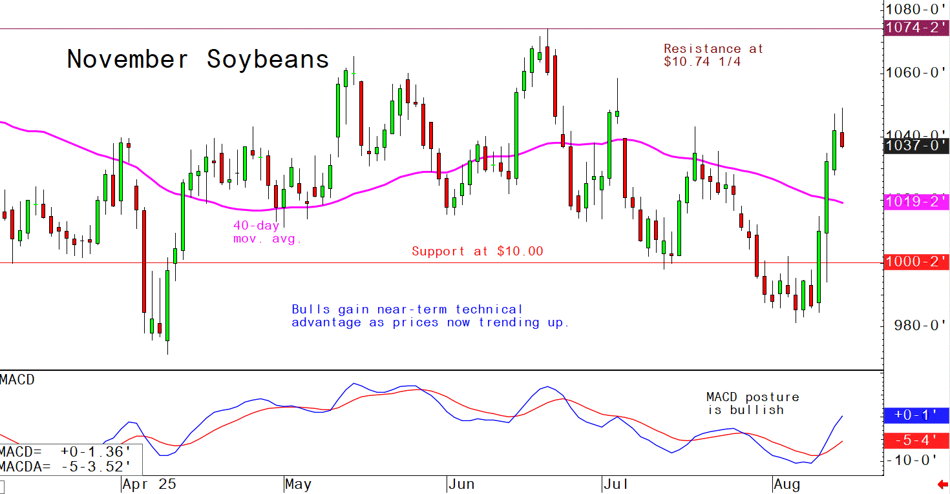
Soybean Meal
Fundamental Recommendation: The Chinese announcement will have a meaningful impact on the US soybean meal market. At the same time, the recent announcement by Bill Gates could reduce biofuel efforts cutting the potential for overproduction in soybean meal, which has pressured prices. That said, the lower prices drove record consumption, so it is likely feed rations may get a little tighter in reaction to higher prices, leaving us marginally bullish on flat prices for protein meals, but bullish for basis across the complex. Given the freshness of the news, we are not as comfortable putting out a precise target this week but will work through the analysis and have an updated price forecast and specific recommendations next week.

Fundamental Bullish Factor – Shift in biofuel policy priorities could lead to reduction in meal production
Fundamental Bullish Factor – Resumption of Chinese purchases tightens US domestic market
Fundamental Bearish Factor – Chinese pork demand slowing, potentially reducing Chinese soybean meal use.
Fundamental Bearish Factor – Improving growing conditions in Argentina ahead of planting

Technical Recommendation: Sideways to Higher.

Technical Bullish Factor – Prices now trending up on daily bar chart.
Technical Bullish Factor – Prices above key 40-day moving average.
Technical Bullish Factor – Spreaders are unwinding short meal, long bean oil spreads.
Technical Bearish Factor – Market is short-term overbought, technically.
Technical Bearish Factor – Longer-term charts are not bullish.

Soybean Meal (Continued)

CBOT Soybean Meal Technicals
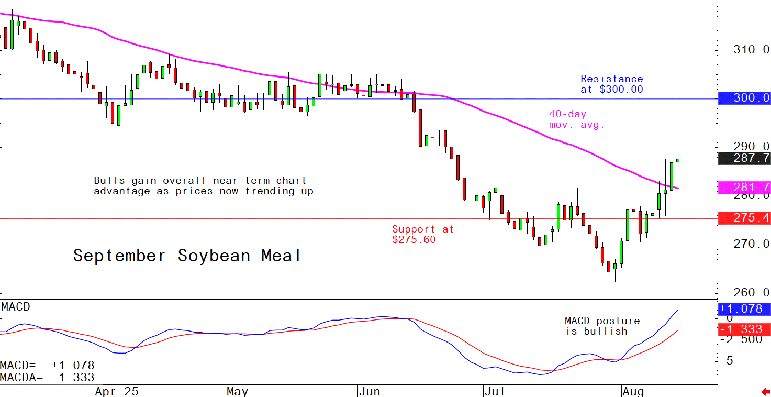

Soybean Oil
Fundamental Recommendation: Cross currents fundamentally, the Chinese announcement reduces the volume of beans available to the domestic market supporting soybean complex basis levels. At the same time, Bill Gates announcement that “Climate Change” will not end the world in a decade and in fact humanity will thrive, suggests the wind is coming out of the potentially stalled world-wide effort to drive SAF consumption. Still believe the SA crop will force the complex lower and if doubts about US biofuel policy take root, soybean oil could lead the product side of the complex lower. Given the freshness of the news, we are not as comfortable putting out a precise target this week but will work through the analysis and have an updated price forecast and specific recommendations next week.

Fundamental Bullish Factor – US inventories remain tight despite record crushing volumes
Fundamental Bullish Factor – Resumption of Chinese purchases will tighten domestic soybean market
Fundamental Bearish Factor – Delays in implementation of Brazilian biofuel mandates raise export competition
Fundamental Bearish Factor – Bill Gates admission that humanity will thrive in the coming years, despite rising world temperatures

Technical Recommendation: Sideways to Lower.

Technical Bullish Factor – Solid chart support levels just below the market.
Technical Bullish Factor – Rallies in soybeans and meal will limit downside in bean oil.
Technical Bullish Factor – Weekly chart is still friendly.
Technical Bearish Factor – Price downtrend in place on daily chart.
Technical Bearish Factor – Prices below key 40-day moving average.
Technical Bearish Factor – Slumping crude oil prices bearish for bean oil.

Soybean Oil (Continued)

CBOT Soybean Oil Technicals
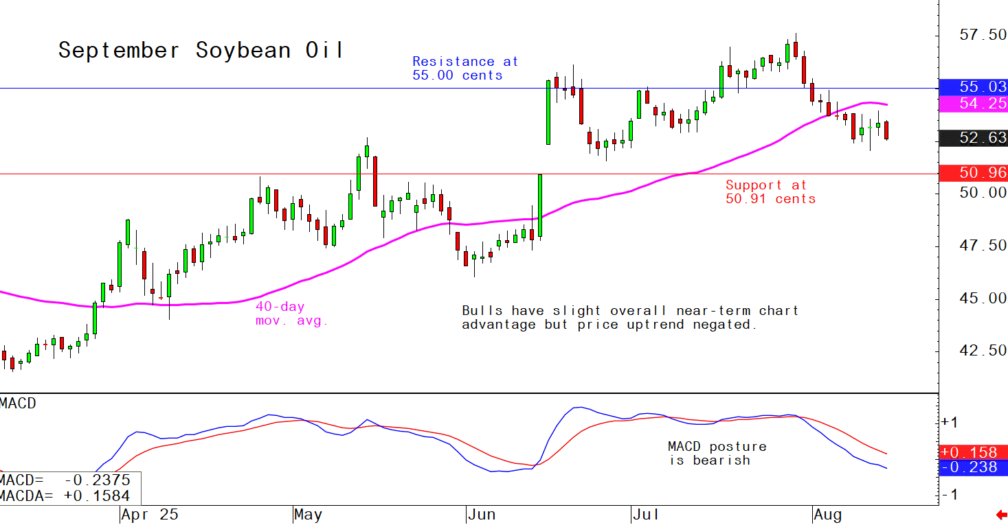

Agricultural Prices

